

NAME: K.SANJAI

REGISTER NO:192325139

COURSE CODE:CSA0477

COURSE NAME: OPERATING SYSTEMS

1. **Create a new process by invoking the appropriate system call. Get the process identifier of the currently running process and its respective parent using system calls and display the same using a C program.**

**AIM:** Create a new process by invoking the appropriate system call. Get the process identifier of the currently running process and its respective parent using system calls and display the same using a C program.

**ALGORITHM:**

1. Include necessary headers: Include the necessary header files like

<stdio.h> and <unistd.h> for using system calls.

1. Declare variables: Declare variables to hold the process ID (pid_t pid)and the parent process ID (pid_t ppid).
2. Get the current process ID: Use the getpid() system call to retrieve theprocess ID of the current process.
3. Get the parent process ID: Use the getppid() system call to retrieve theparent process ID.
4. Display the process IDs: Print the process IDs to the console.
5. Create a new process: Use the fork() system call to create a new process. Check the return value of fork() to determine whether the code is running in the parent or child process.
6. Display process IDs in child and parent processes: Depending on whether the process is the parent or the child, display the respective processIDs.

**PROGRAM:**

#include<stdio.h> #include<unistd.h>int main()

{

printf("Process ID: %d\n", getpid() ); printf("Parent Process ID: %d\n", getpid() );return 0;

}

# OUTPUT

# 

1. **Identify the system calls to copy the content of one file toanother and illustrate the same using a C program**

**AIM:** Identify the system calls to copy the content of one file to anotherand illustrate the same using a C program

**ALGORITHM:**

* + Include necessary headers:
  + Include the necessary header files like <stdio.h>, <fcntl.h>, and

<unistd.h> for working with file-related system calls.

* + Declare variables:
  + Declare variables to hold file descriptors, buffer, and other necessary information.
  + Open the source and destination files:
  + Use the open system call to open the source and destination files,obtaining file descriptors for each.
  + Read from the source file:
  + Use the read system call to read data from the source file into abuffer.
  + Write to the destination file:
  + Use the write system call to write the data read from the source fileinto the destination file.
  + Close the files:

Use the close system call to close the source and destination files.

**PROGRAM:**

#include <stdio.h> #include <stdlib.h>

int main()

{

FILE *fptr1, *fptr2; char filename[100], c;

printf("Enter the filename to open for reading \n"); scanf("%s", filename);

fptr1 = fopen(filename, "r");if (fptr1 == NULL)

{

printf("Cannot open file %s \n", filename); exit(0);

}

printf("Enter the filename to open for writing \n"); scanf("%s", filename);

fptr2 = fopen(filename, "w");if (fptr2 == NULL)

{

printf("Cannot open file %s \n", filename); exit(0);

}

c = fgetc(fptr1); while (c != EOF)

{

fputc(c, fptr2); c

= fgetc(fptr1);

}

printf("\nContents copied to %s", filename); fclose(fptr1);

fclose(fptr2); return 0;

}

OUTPUT

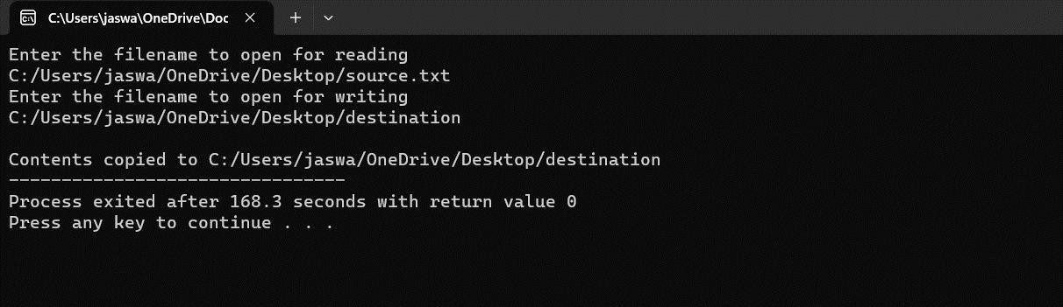

1. **Design a CPU scheduling program with C using First ComeFirst Served**

**technique with the following considerations.**

1. **All processes are activated at time 0.**
2. **Assume that no process waits on I/O devices.**

**AIM:** Design a CPU scheduling program with C using First ComeFirst Served technique with the

b.Assume that no process waits on I/O devices.

**ALGORITHM:**

1. Include necessary headers:
2. Include the necessary header files like <stdio.h> for input/output operations.
3. Define the process structure:
4. Define a structure to hold the process information, such as processID, arrival time, burst time, waiting time, and turnaround time.
5. Input the number of processes and their details:

Input the number of processes and their arrival time and burst time.

1. Sort processes by arrival time (if not given):

If the processes are not already sorted by arrival time, sort them based7.Calculate waiting time and turnaround time.

1. Display the scheduling information:

Display the process details including process ID, arrival time, bursttime, waiting time, and turnaround time.

**PROGRAM:**

#include <stdio.h>int main()

{

int A[100][4];

int i, j, n, total = 0, index, temp;float avg_wt, avg_tat;

printf("Enter number of process: "); scanf("%d", &n);

printf("Enter Burst Time:\n");for (i

= 0; i < n; i++) {

printf("P%d: ", i + 1); scanf("%d", &A[i][1]); A[i][0] = i + 1;

}

for (i = 0; i < n; i++) {

index = i;

for (j = i + 1; j < n; j++)

if (A[j][1] < A[index][1]) index = j;

temp = A[i][1]; A[i][1] =

A[index][1];A[index][1]

= temp;

temp = A[i][0]; A[i][0] =

A[index][0];A[index][0]

= temp;

}

A[0][2] = 0;

for (i = 1; i < n; i++) {

A[i][2] = 0;

for (j = 0; j < i; j++)

A[i][2] += A[j][1];

total += A[i][2];

}

avg_wt = (float)total / n; total = 0;

printf("P BT WT TAT\n");

for (i = 0; i < n; i++) {

A[i][3] = A[i][1] + A[i][2];

total += A[i][3];

printf("P%d %d %d %d\n", A[i][0],A[i][1],

A[i][2], A[i][3]);

}

avg_tat = (float)total / n;

printf("Average Waiting Time= %f", avg_wt); printf("\nAverage Turnaround Time= %f", avg_tat);

}

# OUTPUT

# 

1. **Construct a scheduling program with C that selects the waiting process with the smallest execution time to execute next.**

**AIM:** Construct a scheduling program with C that selects the waiting process with the smallest execution time to execute next.

# ALGORITHM:

1. Include necessary headers:

Include the necessary header files like <stdio.h> for input/outputoperations.

1. Define the process structure:
2. Define a structure to hold the process information, such as process ID,arrival time,

burst time, waiting time, and turnaround time.

1. Input the number of processes and their details:

Input the number of processes and their arrival time and burst time.4.Sort processes by burst time:

Sort the processes based on burst time in ascending order.5.Calculate waiting time and turnaround time:

Calculate the waiting time and turnaround time for each process basedon the SJF scheduling algorithm.

6.Display the scheduling information:

Display the process details including process ID, arrival time, bursttime, waiting time, and turnaround time.

**PROGRAM:**

#include<stdio.h>int main()

{

int bt[20],p[20],wt[20],tat[20],i,j,n,total=0,pos,temp;float avg_wt,avg_tat;

printf("Enter number of process:"); scanf("%d",&n);

printf("nEnter Burst Time:\n");for(i=0;i<n;i++)

{

printf("p%d:",i+1);

scanf("%d",&bt[i]); p[i]=i+1;

}

for(i=0;i<n;i++){ pos=i; for(j=i+1;j<n;j++)

{

if(bt[j]<bt[pos]) pos=j;

}

temp=bt[i]; bt[i]=bt[pos]; bt[pos]=temp;

temp=p[i]; p[i]=p[pos]; p[pos]=temp;

}

wt[0]=0;

for(i=1;i<n;i++)

{

wt[i]=0; for(j=0;j<i;j++)

wt[i]+=bt[j];

total+=wt[i];

}

avg_wt=(float)total/n; total=0;

printf("nProcesst Burst Time tWaiting TimetTurnaround Time\n"); for(i=0;i<n;i++)

{

tat[i]=bt[i]+wt[i]; total+=tat[i];

printf("np%dtt %dtt %dttt%d",p[i],bt[i],wt[i],tat[i]);

}

avg_tat=(float)total/n;

printf("nnAverage Waiting Time=%f",avg_wt); printf("nAverage Turnaround Time=%fn",avg_tat);

}

**OUTPUT**

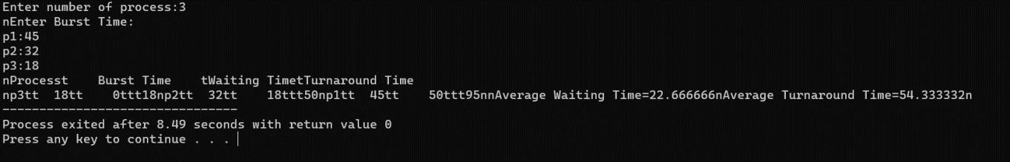

1. **Construct a scheduling program with C that selects the waiting processwith the highest priority to execute next.**

**Aim:-** Construct a scheduling program with C that selects the waiting processwith the highest priority to execute next.

**Algorithm:-**

* 1. Initialize the necessary data structures to store process information,including process ID, arrival time, burst time, and priority.
  2. Read the number of processes (N) from the user.
  3. For each process, read the following information:
  4. Process ID (PID)
  5. Arrival Time
  6. Burst Time (time required for execution)
  7. Priority (lower values indicate higher priority)
  8. Sort the processes based on their arrival time in ascending order.
  9. Initialize a variable current_time to 0 (representing the current time in thesimulation).
  10. Initialize a variable completed to 0 (to keep track of the number ofcompleted processes).
  11. Create a priority queue or data structure to store processes based on theirpriority.
  12. Initialize a variable total_waiting_time to 0.
  13. While there are still processes to execute (i.e., completed < N), repeat thefollowing:
      1. For each process that has arrived but has not been completed, add itto the priority queue.
      2. Pop the process with the highest priority from the queue.
      3. Calculate the waiting time for the process as current_time - arrivaltime.
      4. Add the waiting time to total_waiting_time.
      5. Update current_time by adding the process's burst time.
      6. Print the process ID, arrival time, burst time, waiting time, and turnaround time.
      7. Mark the process as completed.
  14. Calculate the average waiting time as total_waiting_time / N.15.Print the average waiting time.

**Program:-**

#include<stdio.h>

struct priority_scheduling {char process_name;

int burst_time; int waiting_time;

int turn_around_time;int priority;

};

int main() {

int number_of_process;int total = 0;

struct priority_scheduling temp_process;int ASCII_number = 65;

int position;

float average_waiting_time; float average_turnaround_time;

printf("Enter the total number of Processes: "); scanf("%d", & number_of_process);

struct priority_scheduling process[number_of_process]; printf("\nPlease Enter the Burst Time and Priority of each process:\n");for (int i = 0; i < number_of_process; i++) {

process[i].process_name = (char) ASCII_number;

printf("\nEnter the details of the process %c \n", process[i].process_name);

printf("Enter the burst time: "); scanf("%d", & process[i].burst_time);printf("Enter the priority: "); scanf("%d", & process[i].priority); ASCII_number++; }

for (int i = 0; i < number_of_process; i++) { position = i;

for (int j = i + 1; j < number_of_process; j++) {

if (process[j].priority > process[position].priority)position

= j; }

temp_process = process[i]; process[i] = process[position]; process[position] = temp_process; } process[0].waiting_time = 0;

for (int i = 1; i < number_of_process; i++) { process[i].waiting_time = 0;

for (int j = 0; j < i; j++) {

process[i].waiting_time += process[j].burst_time; } total += process[i].waiting_time; }

average_waiting_time = (float) total / (float) number_of_process;

total = 0;

printf("\n\nProcess_name \t Burst Time \t Waiting Time \t Turnaround Time\n");

printf(" \n"); for (int i = 0; i < number_of_process; i++) {

process[i].turn_around_time = process[i].burst_time + process[i].waiting_time;

printf("\t %c \t\t %d \t\t %d \t\t %d", process[i].process_name, process[i].burst_time,

process[i].waiting_time,

process[i].turn_around_time);

printf("\n \n"); } average_turnaround_time = (float) total / (float) number_of_process; printf("\n\n Average Waiting Time : %f", average_waiting_time); printf("\n Average Turnaround Time: %f\n", average_turnaround_time);return 0;

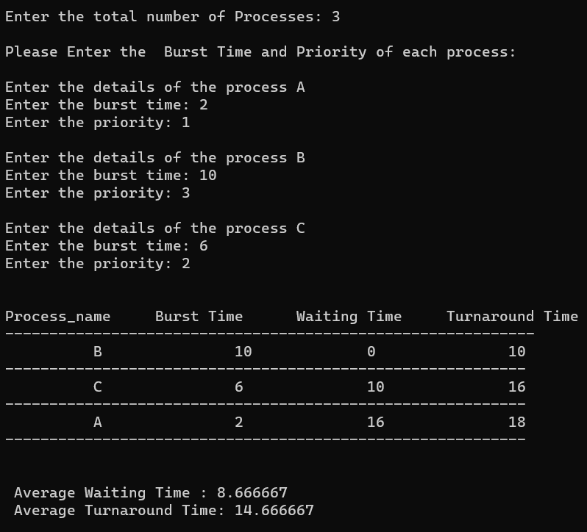

1. **Construct a C program to simulate Round Robin scheduling algorithmwith C. Aim:-** Construct a C program to simulate Round Robin scheduling algorithmwith C. **Algorithm:-**
   1. Initialize the necessary data structures to store process information,including process ID, burst time, and remaining time.
   2. Read the number of processes (N) from the user.
   3. Read the time quantum (slice time) from the user.
   4. For each process, read the following information:
   5. Process ID (PID)
   6. Burst Time (time required for execution)
   7. Create a queue data structure to store the processes.
   8. Enqueue all processes into the queue.
   9. Initialize a variable current_time to 0 (representing the current time in thesimulation).
   10. Initialize a variable total_waiting_time to 0. 11.While the queue is not empty, repeat the following:
       1. Dequeue a process from the front of the queue.
       2. Calculate the execution time for the process, which is the minimumof the time quantum and the remaining time for the process.
       3. Update the process's remaining time.
       4. Update current_time by adding the execution time.
       5. If the process still has remaining time, enqueue it back into thequeue.
       6. Calculate the waiting time for the process as current_time - arrivaltime, where arrival time is the time when the process was first enqueued.
       7. Add the waiting time to total_waiting_time. 12.Calculate the average waiting time as total_waiting_time / N.13.Print the average waiting time.

**Program:-** #include<stdio.h> #include<conio.h>int main()

{

int i, NOP, sum=0,count=0, y, quant, wt=0, tat=0, at[10], bt[10], temp[10];float avg_wt, avg_tat;

printf(" Total number of process in the system: "); scanf("%d", &NOP);

y = NOP;

for(i=0; i<NOP; i++)

{

printf("\n Enter the Arrival and Burst time of the Process[%d]\n", i+1);printf(" Arrival time is: \t");

scanf("%d", &at[i]);

printf(" \nBurst time is: \t"); scanf("%d", &bt[i]); temp[i] = bt[i];

}

printf("Enter the Time Quantum for the process: \t"); scanf("%d", &quant);

printf("\n Process No \t\t Burst Time \t\t TAT \t\t Waiting Time ");for(sum=0, i = 0; y!=0; )

{

if(temp[i] <= quant && temp[i] > 0)

{

sum = sum + temp[i]; temp[i] = 0;

count=1;

}

else if(temp[i] > 0)

{

temp[i] = temp[i] - quant;sum

= sum + quant;

}

if(temp[i]==0 && count==1)

{

y--;

printf("\nProcess No[%d] \t\t %d\t\t\t\t %d\t\t\t %d", i+1, bt[i], sum-at[i], sum- at[i]-bt[i]);

wt = wt+sum-at[i]-bt[i];tat

= tat+sum-at[i]; count =0;

}

if(i==NOP-1)

{

i=0;

}

else if(at[i+1]<=sum)

{

i++;

}

else

{

i=0;

}

}

avg_wt = wt * 1.0/NOP; avg_tat = tat * 1.0/NOP;

printf("\n Average Turn Around Time: \t%f", avg_wt);printf("\n Average Waiting Time: \t%f", avg_tat); getch();

}

**OUTPUT**

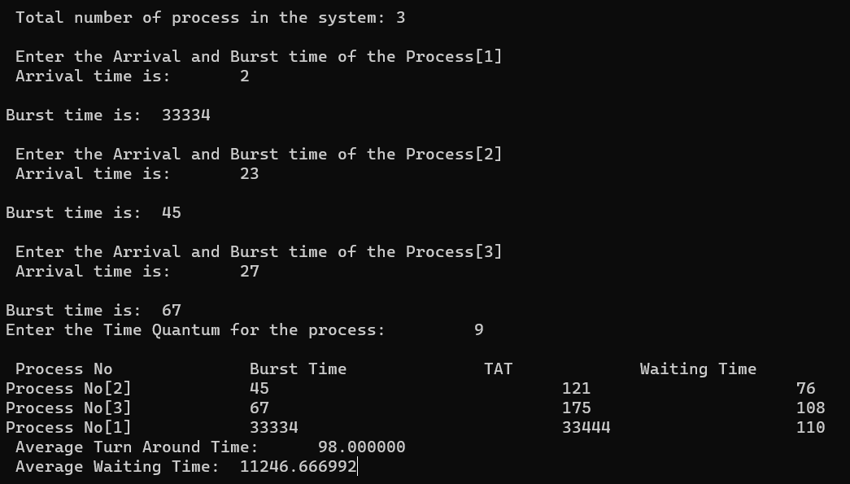

1. **Construct a C program to implement non-preemptive SJFalgorithm**

**AIM:** Construct a C program to implement non-preemptive SJF algorithm

# ALGORITHM:

* 1. Include necessary headers:

Include the necessary header files like <stdio.h> for input/outputoperations.

* 1. Define the process structure:

Define a structure to hold the process information, such as processID, arrival time, burst time, waiting time, and turnaround time.

* 1. Input the number of processes and their details:

Input the number of processes and their arrival time and bursttime.

* 1. Sort processes by burst time:

Sort the processes based on burst time in ascending order.

* 1. Calculate waiting time and turnaround time:

Calculate the waiting time and turnaround time for each processbased on the non- preemptive SJF scheduling algorithm.

* 1. Display the scheduling information:

Display the process details including process ID, arrival time,burst time, waiting time, and turnaround time.

**PROGRAM:**

#include<stdio.h>int main()

{

int at[10],bt[10],pr[10];int n,i,j,temp,time=0,count,over=0,sum_wait=0,sum_turnaround=0,start;

float avgwait,avgturn;

printf("Enter the number of processes\n"); scanf("%d",&n);

for(i=0;i<n;i++)

{

%d\n",i+1);

}

printf("Enter the arrival time and execution time for process

scanf("%d%d",&at[i],&bt[i]); pr[i]=i+1;

for(i=0;i<n-1;i++)

{

for(j=i+1;j<n;j++)

{

if(at[i]>at[j])

{

temp=at[i]; at[i]=at[j]; at[j]=temp; temp=bt[i];

bt[i]=bt[j]; bt[j]=temp; temp=pr[i]; pr[i]=pr[j]; pr[j]=temp;

}

}

}

printf("\n\nProcess\t|Arrival time\t|Execution time\t|Start time\t|End time\t|waiting time\t|Turnaround time\n\n");

while(over<n)

{

count=0; for(i=over;i<n;i++)

{

if(at[i]<=time) count++;

else break;

}

if(count>1)

{

for(i=over;i<over+count-1;i++)

{

for(j=i+1;j<over+count;j++)

{

if(bt[i]>bt[j])

{

temp=at[i]; at[i]=at[j]; at[j]=temp; temp=bt[i]; bt[i]=bt[j];

bt[j]=temp; temp=pr[i];

pr[i]=pr[j]; pr[j]=temp;

}

}

}

}

start=time; time+=bt[over];

printf("p[%d]\t|\t%d\t|\t%d\t|\t%d\t|\t%d\t|\t%d\t|\t%d\n",pr[over],

at[over],bt[over],start,time,time-at[over]-

bt[over],time-at[over]);

sum_wait+=time-at[over]-bt[over];

sum_turnaround+=time-at[over]; over++;

}

avgwait=(float)sum_wait/(float)n; avgturn=(float)sum_turnaround/(float)n; printf("Average waiting time is %f\n",avgwait); printf("Average turnaround time is %f\n",avgturn);return 0;

}

**OUTPUT**

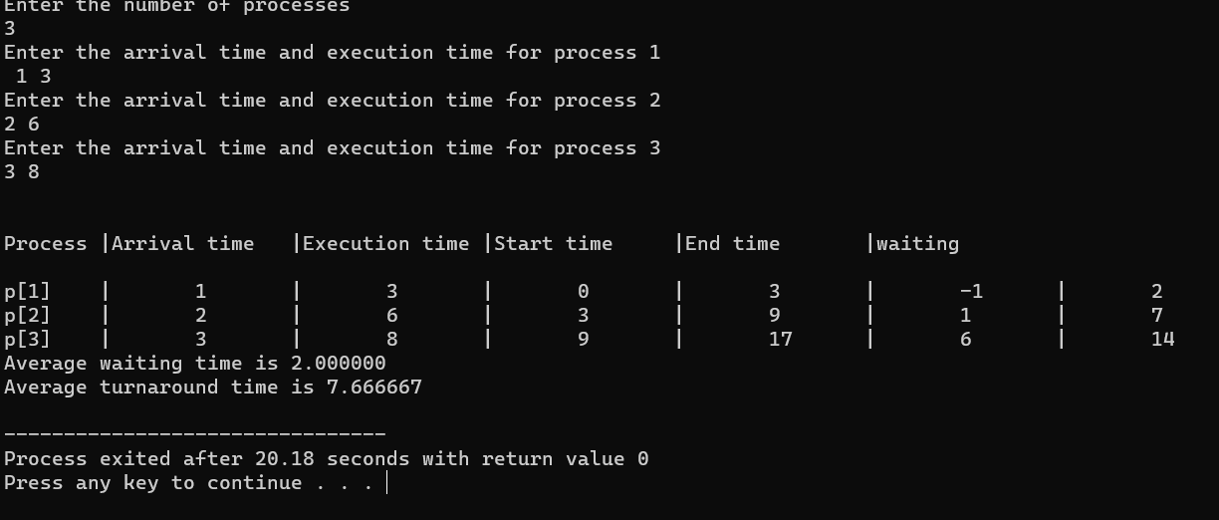

1. **Construct a C program to simulate Round Robin scheduling algorithm with C.**

**AIM:** Construct a C program to simulate Round Robin schedulingalgorithm with C.

# ALGORITHM:

* 1. Include necessary headers:

Include the necessary header files like <stdio.h> for input/output operations.

* 1. Define the process structure:

Define a structure to hold the process information, such as process ID,arrival time, burst time, waiting time, and turnaround time.

* 1. Input the number of processes and their details:

Input the number of processes and their arrival time and burst time.4.Input the time quantum for Round Robin:

Input the time quantum to be used in the Round Robin scheduling.5.Simulate Round Robin scheduling:

Implement the Round Robin scheduling algorithm, including a queue tokeep track of the processes.

6.Display the scheduling information:

Display the process details including process ID, arrival time, burst time,waiting time, and turnaround time.

**PROGRAM:**

#include<stdio.h> #include<conio.h> int main() {

int i, NOP, sum=0,count=0, y, quant, wt=0, tat=0, at[10], bt[10], temp[10]; float avg_wt, avg_tat;

printf(" Total number of process in the system: "); scanf("%d", &NOP);

y = NOP;

for(i=0; i<NOP; i++) {

printf("\n Enter the Arrival and Burst time of the Process[%d]\n", i+1);printf(" Arrival time is: \t");

scanf("%d", &at[i]);

scanf("%d", &bt[i]);

temp[i] = bt[i]; }

printf("Enter the Time Quantum for the process: \t"); scanf("%d", &quant);

printf("\n Process No \t\t Burst Time \t\t TAT \t\t Waiting Time ");for(sum=0, i = 0; y!=0; )

{

if(temp[i] <= quant && temp[i] > 0)

{

sum = sum + temp[i]; temp[i] = 0;

count=1;

}

else if(temp[i] > 0)

{

temp[i] = temp[i] - quant;sum

= sum + quant;

}

if(temp[i]==0 && count==1)

{

y--;

printf("\nProcess No[%d] \t\t %d\t\t\t\t %d\t\t\t %d", i+1, bt[i], sum-at[i], sum- at[i]-bt[i]);

wt = wt+sum-at[i]-bt[i];tat

= tat+sum-at[i]; count =0;

}

if(i==NOP-1)

{

i=0;

}

else if(at[i+1]<=sum) { i++; }

else { i=0; }

}

avg_wt = wt * 1.0/NOP; avg_tat = tat * 1.0/NOP;

printf("\n Average Turn Around Time: \t%f", avg_wt);printf("\n Average Waiting Time: \t%f", avg_tat); getch();

}

**OUTPUT**

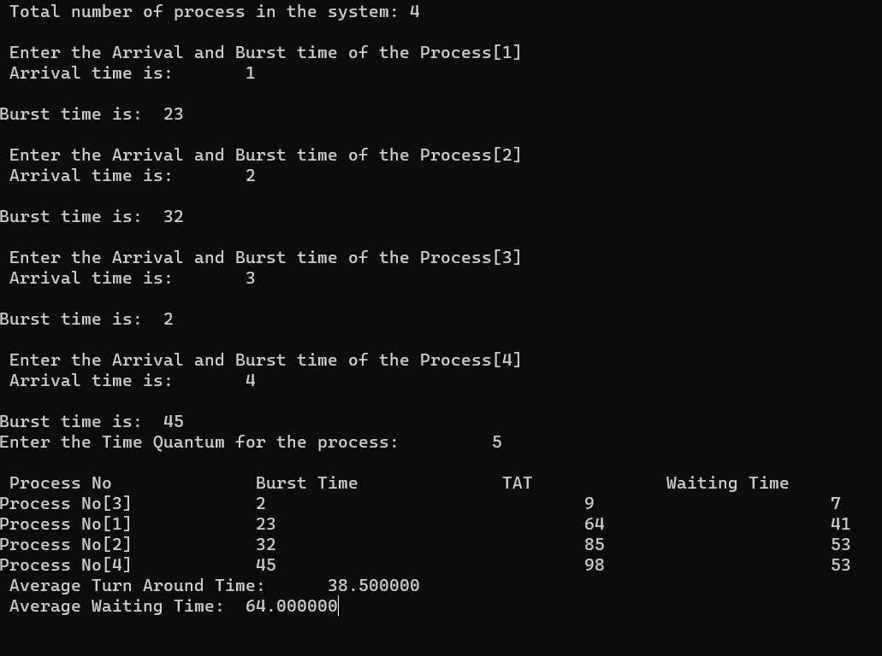

**9 Illustrate the concept of inter-process communication using sharedmemory with a C program**

**AIM:**

To implement the concept of inter-process communication using sharedmemory using C programming.

**ALGORITHM:**

1. Create a shared memory segment:
   * Use shmget() function to create a new shared memory segment or getthe identifier of an existing one.
   * Ensure to handle errors if the shared memory creation fails.
2. Attach shared memory to processes:
   * Use shmat() function to attach the shared memory segment to theprocess address space.
   * This allows processes to read and write data to the shared memory.
3. Read/Write data in shared memory:
   * Processes can read and write data directly to the shared memorylocation.
   * Ensure proper synchronization mechanisms (like semaphores) areused to avoid race conditions and maintain data consistency.
4. Detach shared memory and clean up:
   * Use shmdt() function to detach the shared memory segment from theprocess when done.
   * Optionally, remove the shared memory segment using shmctl() withthe IPC_RMID command.

# PROGRAM:

#include <stdio.h> #include <stdlib.h> #include <string.h> #include <unistd.h> #include <sys/ipc.h> #include <sys/shm.h>

#define SHM_SIZE 1024 // Size of the shared memory segmentint main() { key_t key = ftok("shmfile", 65); // Generate a unique key for the shared

memory segment

// Create a new shared memory segment (or get the identifier of anexisting one)

int shmid = shmget(key, SHM_SIZE, IPC_CREAT | 0666);if (shmid

== -1) {

perror("shmget"); exit(EXIT_FAILURE);

}

// Attach the shared memory segment to the process address space char *shm_ptr = (char*)shmat(shmid, NULL, 0);if

(shm_ptr == (char*)(-1)) {

perror("shmat"); exit(EXIT_FAILURE);

}

// Write data to the shared memory strcpy(shm_ptr, "Hello, shared memory!");

// Detach the shared memory segment from the processif (shmdt(shm_ptr) == -1) {

perror("shmdt"); exit(EXIT_FAILURE);

}

printf("Data written to shared memory: %s\n", shm_ptr);

// Optional: Remove the shared memory segmentif (shmctl(shmid, IPC_RMID, NULL) == -1) {

perror("shmctl"); exit(EXIT_FAILURE);

}

return 0;

}

# OUTPUT:

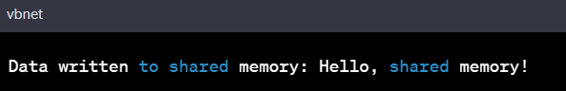

1. **Illustrate the concept of inter-process communication usingmessage queue with a c program**

# AIM :

To implement the concept of inter-process communication using messagequeue with a c program

# ALGORITHM :

1. Create a message queue:
   1. Use msgget() function to create a new message queue or get the identifier of an existing one.
   2. Ensure to handle errors if the message queue creation fails.
2. Send a message to the queue (Producer process):
   1. Define a structure for the message containing necessary data fields.
   2. Populate the message structure with appropriate data.
   3. Use msgsnd() function to send the message to the message queue.
   4. Handle errors if message sending fails.
3. Receive a message from the queue (Consumer process):
   1. Define a structure for the message to receive data.
   2. Use msgrcv() function to receive a message from the message queue.
   3. Process the received message as needed.
   4. Handle errors if message receiving fails.
4. Remove the message queue (Optional):
   1. Use msgctl() function with IPC_RMID command to remove the message queue when it's no longer needed.

# PROGRAM :

#include <stdio.h> #include <stdlib.h> #include <string.h> #include <unistd.h> #include <sys/types.h> #include <sys/ipc.h> #include <sys/msg.h>

struct message { long msg_type;

char msg_text[100];

};

int main() {

key_t key = ftok("msgqfile", 65); // Generate a unique key for themessage queue

// Create a new message queue (or get the identifier of an existing one)int msgid = msgget(key, IPC_CREAT | 0666);

if (msgid == -1) { perror("msgget");

exit(EXIT_FAILURE);

}

struct message msg;

msg.msg_type = 1; // Message type (can be any positive number)

// Producer: Send a message to the message queue strcpy(msg.msg_text, "Hello, message queue!");

if (msgsnd(msgid, (void*)&msg, sizeof(msg.msg_text), IPC_NOWAIT) == -1) {

perror("msgsnd"); exit(EXIT_FAILURE);

}

printf("Producer: Data sent to message queue: %s\n", msg.msg_text);

// Consumer: Receive a message from the message queue

if (msgrcv(msgid, (void*)&msg, sizeof(msg.msg_text), 1, 0) == -1) { perror("msgrcv");

exit(EXIT_FAILURE);

}

printf("Consumer: Data received from message queue: %s\n", msg.msg_text);

// Remove the message queue

if (msgctl(msgid, IPC_RMID, NULL) == -1) { perror("msgctl");

exit(EXIT_FAILURE);

}

return 0;

}

# OUTPUT :

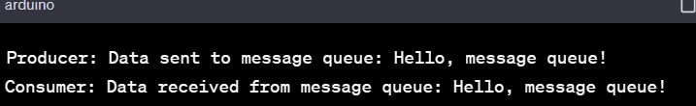

1. **Illustrate the concept of multithreading using a C program**

# AIM :

To implement the concept of multithreading using C program

# ALGORITHM :

Include Necessary Libraries:

Include the necessary header files for multithreading. For POSIXthreads in C, include pthread.h.

1. Define Thread Function:
   1. Define a function that will be executed by the threads. This function should have a void* return type and a void* parameter, whichcan be used to pass data to the thread.
2. Create Threads:
   1. In the main function or any other function, create thread objectsusing pthread_t.
   2. Use pthread_create() to create threads and specify the threadfunction as well as any parameters to pass.
3. Thread Execution:
   1. Threads execute concurrently and perform the tasks defined in thethread function.
4. Synchronization and Coordination (Optional):
   1. Use synchronization mechanisms such as mutexes, semaphores, or condition variables to coordinate the execution of threads and ensure dataconsistency.
5. Wait for Threads to Complete (Optional):
   1. Use pthread_join() to wait for threads to finish their execution ifthe main thread needs to synchronize with the created threads.
   2. Thread Termination (Optional):
   3. Threads can exit by returning from the thread function or by calling pthread_exit(). The main thread can also call pthread_exit() to terminate the entire process.

# PROGRAM :

#include <stdio.h> #include <pthread.h>

void* threadFunction(void* arg) {char* message = (char*)arg; printf("%s\n", message);

return NULL;

}

int main() {

pthread_t thread1, thread2;

char* message1 = "Hello from Thread 1!";char* message2 = "Hello from Thread 2!";

// Create threads

pthread_create(&thread1, NULL, threadFunction, (void*)message1); pthread_create(&thread2, NULL, threadFunction, (void*)message2);

// Wait for threads to complete pthread_join(thread1, NULL); pthread_join(thread2, NULL);

return 0;

}

# OUTPUT :

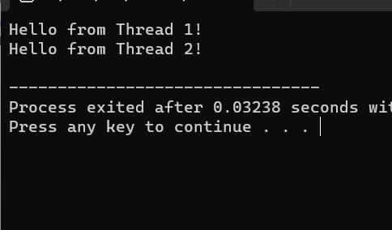

1. **Design a C program to simulate the concept of Dining-Philosophers problem**

# AIM :

To design a C program to simulate the concept of Dining-Philosophers problem

# ALGORITHM :

* 1. Initialize Semaphores:
     1. Create an array of semaphores, one for each philosopher, to controlaccess to the chopsticks.
     2. Initialize each semaphore to 1, indicating that the chopstick isavailable.
  2. Define Philosopher Structure:
     1. Define a structure to represent a philosopher, which includes their ID and the semaphores representing the left and right chopsticks.
  3. Philosopher Lifecycle:
     1. Each philosopher runs as a separate thread. In the thread function:
     2. Think: Philosopher thinks for a random amount of time.
     3. Pick up Chopsticks: Philosopher tries to pick up the left and right chopsticks (acquire semaphores). If both are available, the philosopher proceeds to eat. If not, they release the acquired chopstick(s) and return tothinking.
     4. Eat: Philosopher eats for a random amount of time.
     5. Put Down Chopsticks: Philosopher releases the left and right chopsticks (release semaphores) after eating.
     6. Repeat the above steps indefinitely to simulate the philosopher's

life cycle.

* 1. Implement Deadlock Avoidance:
     1. To avoid deadlock, impose a constraint such that a philosopher can only pick up both chopsticks if both are available.
     2. One way to achieve this is by introducing a global semaphore that

limits the number of philosophers allowed to pick up chopsticks simultaneously. For example, if there are 5 philosophers, allow at most 4philosophers to pick up chopsticks simultaneously. This prevents the circular wait condition and avoids deadlock.

* 1. Compile and Run:
     1. Compile the program with appropriate multithreading flags (e.g., - pthread for gcc on Unix-based systems).
     2. Run the program to observe the dining philosophers problem

simulation.

# PROGRAM :

#include <stdio.h> #include <stdlib.h> #include <pthread.h> #include <unistd.h>

#define NUM_PHILOSOPHERS 5

pthread_mutex_t chopsticks[NUM_PHILOSOPHERS];

void* philosopherLifeCycle(void* arg) {int id =

*((int*)arg);

int left_chopstick = id;

int right_chopstick = (id + 1) % NUM_PHILOSOPHERS;

while (1) {

// Think

printf("Philosopher %d is thinking...\n", id);

// Pick up chopsticks pthread_mutex_lock(&chopsticks[left_chopstick]); pthread_mutex_lock(&chopsticks[right_chopstick]);

// Eat

printf("Philosopher %d is eating...\n", id); sleep(rand() % 3 + 1); // Eating time

// Put down chopsticks pthread_mutex_unlock(&chopsticks[left_chopstick]); pthread_mutex_unlock(&chopsticks[right_chopstick]);

// Repeat the cycle

}

}

int main() {

pthread_t philosophers[NUM_PHILOSOPHERS];int philosopher_ids[NUM_PHILOSOPHERS];

// Initialize mutex locks

for (int i = 0; i < NUM_PHILOSOPHERS; ++i) {

pthread_mutex_init(&chopsticks[i], NULL);

}

// Create philosopher threads

for (int i = 0; i < NUM_PHILOSOPHERS; ++i) {

philosopher_ids[i] = i;

pthread_create(&philosophers[i], NULL, philosopherLifeCycle, (void*)&philosopher_ids[i]);

}

// Wait for threads to finish (although they run indefinitely)for (int i = 0; i < NUM_PHILOSOPHERS; ++i) {

pthread_join(philosophers[i], NULL);

}

// Destroy mutex locks

for (int i = 0; i < NUM_PHILOSOPHERS; ++i) {

pthread_mutex_destroy(&chopsticks[i]);

}

return 0;

}

# OUTPUT :

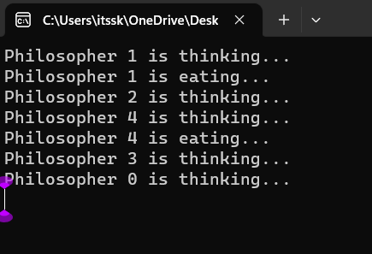

1. **Construct a C program to implement various memory allocationstrategies.**

# AIM :

To construct a C program to implement various memory allocationstrategies.

# ALGORITHM :

1. Include Necessary Libraries:

Include the necessary header files such as stdio.h, stdlib.h, etc.

1. Define Process Control Block (PCB) Structure:
   1. Define a structure to represent a Process Control Block (PCB) that
   2. contains information about each process, including process ID,
   3. memory size, and allocation status.
2. Implement Memory Allocation Functions:
   1. Implement functions for memory allocation strategies like First Fit, Best Fit, and Worst Fit.
   2. Each function should search for a suitable block of memory in the

memory pool based on the specific strategy (first fit, best fit, or worst fit).

* 1. Allocate memory to the process by updating the allocation status in the PCB and updating the memory pool accordingly.

1. Implement Memory Deallocation Function:
   1. Implement a function to deallocate memory occupied by a process.
   2. Update the allocation status in the PCB and release the memory block, merging it with adjacent free blocks if necessary.
2. Main Function:
   1. In the main function, initialize the memory pool (an array representing the available memory).
   2. Create PCBs for processes with specific memory requirements.
   3. Call the appropriate memory allocation functions based on the desired strategy for each process.
   4. Deallocate memory for completed processes using the memory

deallocation function.

1. Print Memory Allocation Status:
   1. Implement a function to print the memory allocation status after

each allocation and deallocation operation.

1. Compile and Run:
   1. Compile the program and run it to observe how different memory allocation strategies work.

# PROGRAM :

#include<stdio.h>

void bestfit(int mp[],int p[],int m,int n){int j=0;

for(int i=0;i<n;i++){

if(mp[i]>p[j]){

printf("\n%d fits in %d",p[j],mp[i]);

mp[i]=mp[i]-p[j++]; i=i-1;

}

}

for(int i=j;i<m;i++)

{

printf("\n%d must wait for its process",p[i]);

}

}

void rsort(int a[],int n){ for(int i=0;i<n;i++){

for(int j=0;j<n;j++){

if(a[i]>a[j]){

int t=a[i]; a[i]=a[j]; a[j]=t;

}

}

}

}

void sort(int a[],int n){ for(int i=0;i<n;i++){

for(int j=0;j<n;j++){

if(a[i]<a[j]){

int t=a[i]; a[i]=a[j]; a[j]=t;

}

}

}

}

void firstfit(int mp[],int p[],int m,int n){ sort(mp,n);

sort(p,m); bestfit(mp,p,m,n);

}

void worstfit(int mp[],int p[],int m,int n){ rsort(mp,n);

sort(p,m); bestfit(mp,p,m,n);

}

int main(){

int m,n,mp[20],p[20],ch; printf("Number of memory partition : ");scanf("%d",&n);

printf("Number of process : "); scanf("%d",&m);

printf("Enter the memory partitions : \n");for(int i=0;i<n;i++){

scanf("%d",&mp[i]);

}

printf("ENter process size : \n"); for(int i=0;i<m;i++){

scanf("%d",&p[i]);

}

printf("1. Firstfit\t2. Bestfit\t3. worstfit\nEnter your choice : "); scanf("%d",&ch);

switch(ch){ case 1:

bestfit(mp,p,m,n); break;

case 2:

firstfit(mp,p,m,n); break;

case 3:

default:

worstfit(mp,p,m,n); break;

printf("invalid"); break;

}

}

# OUTPUT :

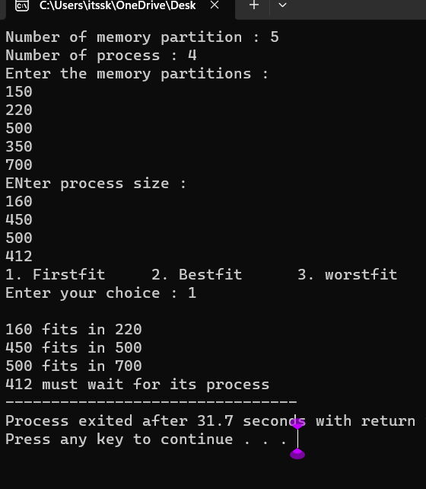

1. **Construct a C program to organize the file using single leveldirectory AIM:**

To construct a c program to organize the file using single level directory

# ALGORITHM :

Step 1: Define Structures

Define structures to represent files and the directory.Step 2:

Initialize Directory

Create a function or code segment to initialize the directory structure. Setthe initial file count to 0.

Step 3: Add Files

Implement a function or code segment to add files to the directory. This function should handle adding files, updating the file count, and handlingerrors if the directory is full.

Step 4: List Files

Create a function or code segment to list all the files in the directory. Thisfunction should iterate through the file list and print the file names.

Step 5: Delete Files (Optional)

Implement a function or code segment to delete files from the directory. This function should handle removing files, updating the file count, and handling errors if the file is not found.

Step 6: Implement User Interface

Create a user interface for interacting with the program. This could be amenu- driven interface where users can choose to add files, list files, delete files, or exit the program.

Step 7: Test the Program

Compile the program using a C compiler and test it by adding files, listing files, and deleting files. Make sure the program handles differentscenarios and errors gracefully.

Step 8: Refine and Expand (Optional)

Refine your program based on testing results. You can also expand the functionality by adding more features, error handling, or optimizing thecode.

Step 9: Document Your Code (Optional)

Document your code by adding comments to explain the functionality ofdifferent sections of your program. This will make it easier for others (and yourself) to understand the code in the future.

Step 10: Compile and Distribute

Once your program is complete and thoroughly tested, compile it into anexecutable file. If you want to distribute the program, you can create an installer or provide the

executable along with necessary instructions.

# PROGRAM :

#include <stdio.h> #include <stdlib.h> #include <fcntl.h> #include <unistd.h>

#define BUFFER_SIZE 4096void copy(){

const char *sourcefile= "C:/Users/itssk/OneDrive/Desktop/sasi.txt";

const char *destination_file="C:/Users/itssk/OneDrive/Desktop/sk.txt";int source_fd = open(sourcefile, O_RDONLY);

int dest_fd = open(destination_file, O_WRONLY | O_CREAT |O_TRUNC, 0666);

char buffer[BUFFER_SIZE]; ssize_t bytesRead, bytesWritten;

while ((bytesRead = read(source_fd, buffer, BUFFER_SIZE)) > 0) {bytesWritten = write(dest_fd, buffer, bytesRead);

}

close(source_fd); close(dest_fd);

printf("File copied successfully.\n");

}

void create()

{

char path[100];

FILE *fp; fp=fopen("C:/Users/itssk/OneDrive/Desktop/sasi.txt","w"); printf("file created successfully");

}

int main(){

int n;

printf("1. Create \t2. Copy \t3. Delete\nEnter your choice: " ); scanf("%d",&n);

switch(n){

case 1: create(); break; case 2:

}}

# OUTPUT :

copy(); break; case 3:

remove("C:/Users/itssk/OneDrive/Desktop/sasi.txt");printf("Deleted successfully");

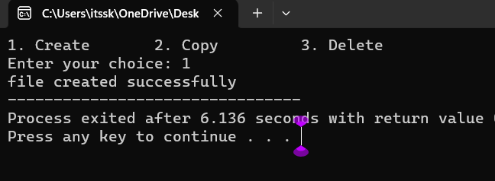

1. **Design a C program to organize the file using two level directorystructure.**

# AIM :

To design a C program to organize the file using two level directorystructure

**Algorithm :**

* 1. Define Structures: Define structures for files and directories. Eachdirectory structure should contain an array for files and an array for subdirectories.
  2. Initialize Root Directory: Create a root directory structure. Thisserves as the starting point for the two-level directory structure.
  3. Add Files to Directories: Implement a function to add files to aspecific directory. Handle adding files, updating the file count, and handling errors if the directory is full.
  4. Add Subdirectories: Implement a function to add subdirectories toa specific directory. Manage adding directories, updating the directory count, and handling errors if the parent directory is full.
  5. List Files and Subdirectories: Create functions to list all the files and subdirectories in a directory. These functions should iterate throughthe file and subdirectory arrays and print their names.
  6. Delete Files and Subdirectories (Optional): Implement functions todelete files and subdirectories from a directory. Handle removing files ordirectories, updating the counts, and handling errors if the file or directory is not found.
  7. Implement User Interface: Design a user interface for interacting with the program. This could be a menu-driven interface where users canadd files, add subdirectories, list files, list subdirectories, delete files, delete subdirectories, or exit the program.
  8. Test the Program: Compile the program and test it thoroughly. Addfiles, add subdirectories, list files, list subdirectories, delete files, and delete subdirectories. Ensure the program handles different scenarios anderrors gracefully.
  9. Refine and Expand (Optional): Refine the program based on testing results. Expand the functionality by adding more features, error handling, or optimizing the code.
  10. Document Your Code (Optional): Document your code by addingcomments to explain the functionality of different sections. This will make it easier for others to understand the code in the future.

# PROGRAM :

#include <stdio.h> #include <stdlib.h>

#include <string.h>int main() {

char mainDirectory[] = "C:/Users/itssk/OneDrive/Desktop";char subDirectory[] = "os";

char fileName[] = "example.txt";char filePath[200];

char mainDirPath[200];

snprintf(mainDirPath, sizeof(mainDirPath), "%s/%s/", mainDirectory,subDirectory);

snprintf(filePath, sizeof(filePath), "%s%s", mainDirPath, fileName);FILE *file

= fopen(filePath, "w");

if (file == NULL) { printf("Error creating file.\n");return 1;

}

fprintf(file, "This is an example file content."); printf("File created successfully: %s\n");

}

# OUTPUT :

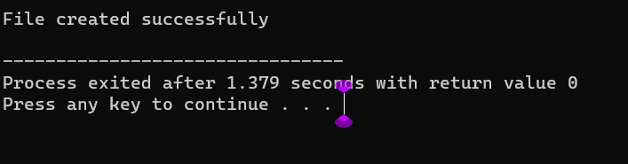

1. **Develop a C program for implementing random access file forprocessing the employee details**

# AIM :

To develop a C program for implementing random access file forprocessing the employee details

# ALGORITHM :

1. Define Structure: Define a structure to represent employee details. Include attributes like employee ID, name, salary, and any other relevantinformation.
2. Open File in Binary Mode: Open a file in binary mode using thefopen function. Specify the file path and mode ("rb+" for reading and writing binary files).
3. Menu-Driven Interface: Create a menu-driven interface for the userto perform operations. Options could include adding a new employee, updating existing employee details, searching for an employee, deleting an employee, listing all employees, and exiting the program.
4. Implement Functions: Implement functions corresponding to eachmenu option. For example, implement functions to add a new employee,update employee details, search for an employee by ID, delete an employee, and list all employees. These functions should perform file operations like reading and writing records.
5. Random Access File Operations: Utilize fseek and ftell functions toperform random access file operations. Use fseek to move the file pointerto the desired record based on the employee ID and ftell to determine the current position of the file pointer.
6. File Read and Write: Implement functions to read and write employee records to the file. Use fread and fwrite functions to read andwrite structures to the file.
7. Error Handling: Implement error handling to deal with situations where the file cannot be opened or when operations like adding, updating,or deleting employees fail. Display appropriate error messages to the user.
8. Close the File: Close the file using the fclose function when theprogram is exiting or when the file operations are completed.
9. Testing: Test the program thoroughly by adding, updating, searching, and deleting employee records. Ensure that the programhandles edge cases and errors gracefully.
10. Documentation (Optional): Add comments and documentation toyour code to explain the functionality of different sections, making it easier for others (and yourself) to understand the code in the future.

# PROGRAM :

#include <stdio.h> #include <stdlib.h> struct Employee {

int empId;

char empName[50]; float empSalary;};

int main() { FILE

*filePtr;

struct Employee emp;

filePtr = fopen("employee.dat", "rb+");if (filePtr == NULL) {

filePtr = fopen("employee.dat", "wb+");if (filePtr == NULL) {

printf("Error creating the file.\n"); return 1; }

}

int choice; do {

printf("\nEmployee Database Menu:\n"); printf("1. Add Employee\n");

printf("2. Display Employee Details\n"); printf("3. Update Employee Details\n"); printf("4. Exit\n");

printf("Enter your choice: "); scanf("%d", &choice); switch (choice) {

case 1:

printf("Enter Employee ID: "); scanf("%d", &emp.empId); printf("Enter Employee Name: ");

scanf("%s", emp.empName); printf("Enter Employee Salary: "); scanf("%f", &emp.empSalary);

fseek(filePtr, (emp.empId - 1) * sizeof(struct Employee), SEEK_SET);

fwrite(&emp, sizeof(struct Employee), 1, filePtr); printf("Employee details added successfully.\n");break;

case 2:

printf("Enter Employee ID to display: "); scanf("%d", &emp.empId);

fseek(filePtr, (emp.empId - 1) * sizeof(struct Employee), SEEK_SET);

fread(&emp, sizeof(struct Employee), 1, filePtr); printf("Employee ID: %d\n", emp.empId); printf("Employee Name: %s\n", emp.empName); printf("Employee Salary:

%.2f\n", emp.empSalary);break; case 3:

printf("Enter Employee ID to update: "); scanf("%d", &emp.empId);

fseek(filePtr, (emp.empId - 1) * sizeof(struct Employee), SEEK_SET);

fread(&emp, sizeof(struct Employee), 1, filePtr); printf("Enter Employee Name: ");

scanf("%s", emp.empName); printf("Enter Employee Salary: "); scanf("%f", &emp.empSalary);

fseek(filePtr, (emp.empId - 1) * sizeof(struct Employee), SEEK_SET);

fwrite(&emp, sizeof(struct Employee), 1, filePtr); printf("Employee details updated successfully.\n");break;

case 4:

break; default:

printf("Invalid choice. Please try again.\n");

}

} while (choice != 4); fclose(filePtr);

return 0;

# OUTPUT :

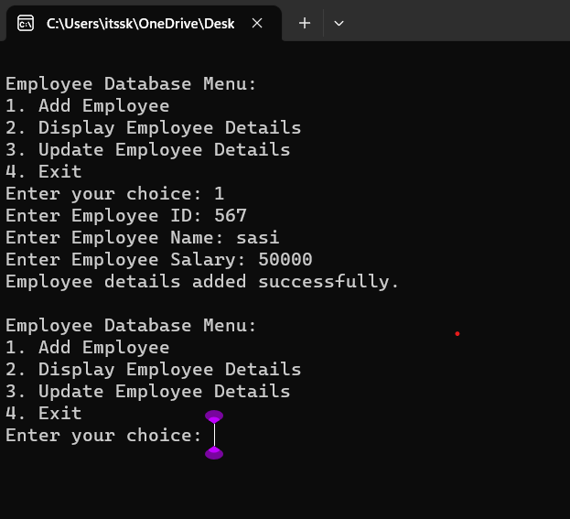

1. **Illustrate the deadlock avoidance concept by simulating Banker’salgorithm using C. AIM :**

To illustrate the deadlock avoidance concept by simulating Banker’salgorithm using C.

# ALGORITHM :

1. Define Data Structures: Define appropriate data structures to storethe available resources, maximum resources, allocated resources, and need matrix for each process.
2. Initialize Matrices: Initialize the available, maximum, allocated,and need matrices based on the system's resources and the maximum demand of each process.
3. Input Request: Implement a function to input resource request fromprocesses. This function should validate if the request is within the maximum limit specified by each process.
4. Safety Algorithm: Implement the Banker's safety algorithm to check if the system is in a safe state. Use the available, allocated, andneed matrices to determine if the system can allocate resources to processes without entering into a deadlock state.
5. Resource Allocation: Implement resource allocation functions to handle the request from processes. Check if the request can be granted safely using the Banker's algorithm. If the request can be granted, updatethe allocated and available matrices accordingly.
6. User Interface: Create a user interface to interact with the program. Allow users to input resource requests and display the current state of the system, including available resources and resource allocation status.
7. Deadlock Scenario: Introduce scenarios where a deadlock can potentially occur (e.g., requesting more resources than available or requesting resources in a circular wait condition).
8. Testing: Test the program with different resource request scenarios.Ensure that the system handles requests properly without entering into a deadlock state. Also, test scenarios where the system should deny requests to prevent deadlock.
9. Documentation (Optional): Add comments and documentation to the code to explain the functionality of different sections. Document the Banker's algorithm steps and how it prevents deadlocks in the system.
10. Error Handling: Implement error handling mechanisms to deal with invalid input, unexpected scenarios, or any issues that might occur during resource allocation and deallocation.

# PROGRAM :

#include <stdio.h>

#define MAX_PROCESSES 5 #define MAX_RESOURCES 3int is_safe();

int available[MAX_RESOURCES] = {3, 3, 2}; // Available instances ofeach resource

int maximum[MAX_PROCESSES][MAX_RESOURCES] = {{7, 5, 3},

{3, 2, 2}, {9, 0, 2}, {2, 2, 2}, {4, 3, 3}};

int allocation[MAX_PROCESSES][MAX_RESOURCES] = {{0, 1, 0},

{2, 0, 0}, {3, 0, 2}, {2, 1, 1}, {0, 0, 2}};

int request_resources(int process_num, int request[]) {

// Check if request can be granted

for (int i = 0; i < MAX_RESOURCES; i++) {

if (request[i] > available[i] || request[i] > maximum[process_num][i]

- allocation[process_num][i])

return 0; // Request cannot be granted

}

// Try allocating resources temporarily

for (int i = 0; i < MAX_RESOURCES; i++) { available[i] -= request[i];

allocation[process_num][i] += request[i];

// Update maximum and need matrix if request is granted maximum[process_num][i] -= request[i];

}

// Check if system is in safe state after allocationif (is_safe()) {

return 1; // Request is granted

} else {

// Roll back changes if not safe

for (int i = 0; i < MAX_RESOURCES; i++) { available[i] += request[i]; allocation[process_num][i] -= request[i]; maximum[process_num][i] += request[i];

}

return 0; // Request is denied

}

}

int is_safe() {

int work[MAX_RESOURCES];

int finish[MAX_PROCESSES] = {0};

// Initialize work array

for (int i = 0; i < MAX_RESOURCES; i++) {work[i]

= available[i];

}

// Check if processes can finishint count = 0;

while (count < MAX_PROCESSES) {int found = 0;

for (int i = 0; i < MAX_PROCESSES; i++) {if (finish[i] == 0) {

int j;

for (j = 0; j < MAX_RESOURCES; j++) {

if (maximum[i][j] - allocation[i][j] > work[j])break;

}

if (j == MAX_RESOURCES) {

// Process can finish, update work and mark as finishedfor (int k

= 0; k < MAX_RESOURCES; k++) {

work[k] += allocation[i][k];

}

finish[i] = 1;

found = 1; count++;

}

}

}

if (found == 0) {

return 0; // No process can finish, not safe state

}

}

return 1; // All processes can finish, safe state

}

int main() {

int process_num, request[MAX_RESOURCES]; printf("Enter process number (0 to 4): "); scanf("%d", &process_num);

printf("Enter resource request (e.g., 0 1 0): ");for (int i = 0; i < MAX_RESOURCES; i++) {

scanf("%d", &request[i]);

}

if (request_resources(process_num, request)) { printf("Request granted.\n");

} else {

printf("Request denied. System is not in safe state.\n");

}

return 0;

# OUTPUT :

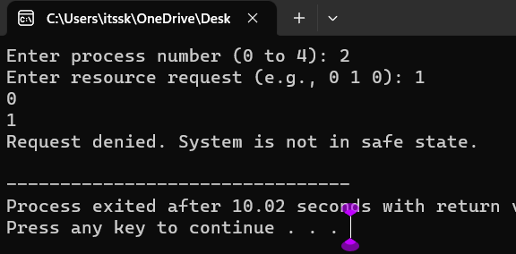

1. **Construct a C program to simulate producer consumer problemusing semaphores.**

# AIM :

To construct a C program to simulate producer consumer problem usingsemaphores.

# ALGORITHM :

1. Include Libraries: Include necessary libraries such as stdio.h,stdlib.h, pthread.h for threads, and semaphore.h for semaphores.
2. Define Constants: Define constants such as the size of the buffer (maximum number of items), number of producer and consumer threads,etc.
3. Declare Global Variables: Declare global variables including the buffer (an array to hold the items), indices to track the next position for inserting and removing items, and semaphores for synchronization.
4. Initialize Semaphores: Initialize semaphores for controlling accessto the buffer, tracking empty spaces in the buffer, and tracking available items in the buffer.
5. Create Producer and Consumer Threads: Create threads for producers and consumers. Each thread should have its own uniqueidentifier (for example, an integer value).
6. Define Producer and Consumer Functions: Implement functions forproducers and consumers. These functions will be executed by the corresponding threads. The producer function will generate items and insert them into the buffer, while the consumer function will remove items from the buffer.
7. Implement Buffer Operations: Implement functions for insertingitems into the buffer (enqueue operation) and removing items from thebuffer (dequeue operation). Use semaphores to control access to the buffer and update the indices accordingly.
8. Synchronize Producer and Consumer Threads: Use semaphores to synchronize the producer and consumer threads. The producer should wait if the buffer is full, and the consumer should wait if the buffer is empty.
9. Handle Thread Joining and Cleanup: After creating the threads,ensure that the main program waits for all threads to finish their execution. Use pthread_join for this purpose. Also, clean up any resources allocated during the program execution.
10. Compile and Run: Compile the C program using a C compiler(such as gcc) and run the executable. Observe the behavior of the producer and consumer threads, ensuring that they are properly synchronized and the buffer operations are correctly implemented.

# PROGRAM :

#include <stdio.h> #include

<pthread.h> #include

<semaphore.h> #include<Windows.h>

#define BUFFER_SIZE 5

#define MAX_ITEMS 10 // Maximum number of items to be produced/consumed

int buffer[BUFFER_SIZE]; sem_t empty, full;

int produced_items = 0, consumed_items = 0;

void* producer(void* arg) {

while (produced_items < MAX_ITEMS) { sem_wait(&empty);

// Critical section: add item to buffer

for (int i = 0; i < BUFFER_SIZE; ++i) {if (buffer[i] == 0) {

buffer[i] = produced_items + 1; printf("Produced: %d\n", buffer[i]);

produced_items++; break;

}

}

sem_post(&full);

Sleep(1); // Sleep for a while

}

return NULL;

}

void* consumer(void* arg) {

while (consumed_items < MAX_ITEMS) { sem_wait(&full);

// Critical section: remove item from bufferfor (int i = 0; i < BUFFER_SIZE; ++i) {

if (buffer[i] != 0) {

printf("Consumed: %d\n", buffer[i]); buffer[i] = 0;

consumed_items++; break;

}

}

sem_post(&empty); Sleep(2); // Sleep for a while

}

return NULL;

}

int main() {

pthread_t producer_thread, consumer_thread;

sem_init(&empty, 0, BUFFER_SIZE);

sem_init(&full, 0, 0);

// Create producer and consumer threads pthread_create(&producer_thread, NULL, producer, NULL); pthread_create(&consumer_thread, NULL, consumer, NULL);

// Wait for threads to finish pthread_join(producer_thread, NULL); pthread_join(consumer_thread, NULL);

// Destroy semaphores sem_destroy(&empty); sem_destroy(&full);

return 0;

}

# OUTPUT :

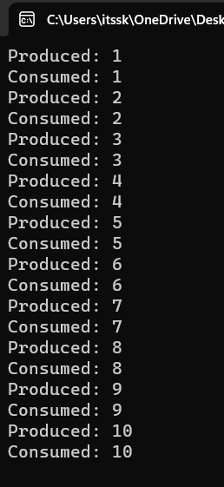

1. **esign a C program to implement process synchronization usingmutex locks. AIM:**

To design a C program to implement process synchronization usingmutex locks.

# ALGORITHM :

Step 1: Include Necessary Libraries: Include the required header files forpthreads and mutex locks.

Step 2: Declare Global Variables: Declare any global variables needed forsynchronization, such as mutex variables.

Step 3: Initialize Mutex: In the main function or initialization function,initialize the mutex using pthread_mutex_init function.

Step 4: Define Functions: Define functions that represent the actions ofthreads. These functions should include the critical sections where the mutex lock is acquired and released.

Step 5: Create Threads: In the main function or any other appropriate function, create threads and assign the functions to execute for each thread. Pass NULL or any necessary data as arguments to the functions.

Step 6: Implement Mutex Synchronization: Inside the functions that represent the actions of threads, use pthread_mutex_lock to acquire themutex lock and pthread_mutex_unlock to release the lock. This ensuresthat only one thread can execute the critical section at a time.

Step 7: Join Threads and Cleanup: In the main function or any other appropriate function, wait for the threads to finish using pthread_join. After the threads have finished their execution, destroy the mutex usingpthread_mutex_destroy function.

Step 8: Compile and Run: Compile the program using a C compiler withthe appropriate flags (for example, -pthread for GCC) to link the pthreadlibrary. Then, run the compiled executable to observe the synchronized behavior of threads due to mutex locks.

# PROGRAM :

#include <stdio.h> #include <pthread.h>

// Shared variablesint counter = 0; pthread_mutex_t mutex;

// Function to be executed by threadsvoid

*threadFunction(void *arg) {

int i;

for (i = 0; i < 1000000; ++i) { }

return NULL;

}

int main() {

pthread_mutex_init(&mutex, NULL); pthread_t thread1, thread2;

pthread_create(&thread1, NULL, threadFunction, NULL); pthread_create(&thread2, NULL, threadFunction, NULL);

// Wait for the threads to finish pthread_join(thread1, NULL); pthread_join(thread2, NULL);

// Destroy the mutex pthread_mutex_destroy(&mutex);

// Print the final value of the counter printf("Final counter value: %d\n", counter);

return 0;

}

# OUTPUT :

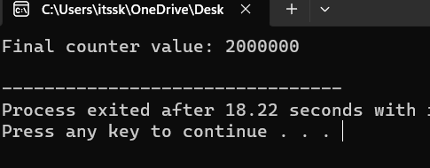

1. **Construct a C program to simulate Reader-Writer problem using semaphores**

# AIM :

To construct a C program to simulate Reader-Writer problem usingsemaphores

# ALGORITHM :

1. Include Libraries: Include necessary libraries for using semaphores, threads, and other required functionalities.
2. Initialize Semaphores: Create semaphores to control access to theshared resources:
   * Semaphore for Readers Count: Initialize a semaphore to 1 (binary semaphore).
   * Semaphore for Writers Count: Initialize a semaphore to 1 (binary semaphore).
   * Semaphore for Readers Waiting: Initialize a semaphore to 1 (binary semaphore).
   * Semaphore for Writers Waiting: Initialize a semaphore to 1 (binary semaphore).
   * Semaphore for Mutex: Initialize a semaphore to 1 (binary semaphore).
3. Reader Function: Create a function for readers to execute. Thisfunction should handle the logic for readers accessing the shared resource.
4. Writer Function: Create a function for writers to execute. This function should handle the logic for writers accessing the shared resource.
5. Implement Reader-Writer Logic: Inside the reader and writer functions, implement the logic that ensures proper synchronization usingsemaphores. Readers should check and update the readers count semaphore and writers should check and update the writers count semaphore.
6. Create Threads: In your main function, create multiple threads forreaders and writers to simulate concurrent access.
7. Join Threads: Use thread joining functions to wait for all threads tocomplete their execution.
8. Clean Up: Destroy the semaphores and perform any necessaryclean-up operations before exiting the program.

# PROGRAM :

#include <stdio.h> #include

<pthread.h> #include

<semaphore.h>

sem_t mutex, writeBlock;

int data = 0, readersCount = 0;

void *reader(void *arg) {int i=0;

while (i<10) { sem_wait(&mutex); readersCount++;

if (readersCount == 1) { sem_wait(&writeBlock);

}

sem_post(&mutex);

// Reading operation

printf("Reader reads data: %d\n", data);

sem_wait(&mutex); readersCount--;

if (readersCount == 0) { sem_post(&writeBlock);

}

sem_post(&mutex);

i++;

}

}

void *writer(void *arg) {int i=0;

while (i<10) { sem_wait(&writeBlock);

// Writing operation data++;

printf("Writer writes data: %d\n", data);

sem_post(&writeBlock);i++;

}

}

int main() {

pthread_t readers, writers; sem_init(&mutex, 0, 1);

sem_init(&writeBlock, 0, 1); pthread_create(&readers, NULL, reader, NULL);pthread_create(&writers, NULL, writer, NULL); pthread_join(readers, NULL); pthread_join(writers, NULL); sem_destroy(&mutex);

sem_destroy(&writeBlock); return 0;

}

# OUTPUT :

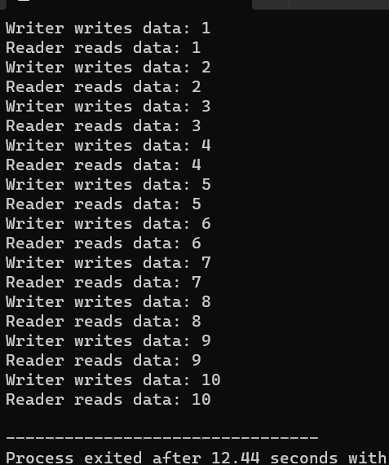

1. **Develop a C program to implement worst fit algorithm ofmemory management.**

# PROGRAM:

#include <stdio.h>

#define MAX_MEMORY 1000int memory[MAX_MEMORY];

// Function to initialize memoryvoid initializeMemory() {

for (int i = 0; i < MAX_MEMORY; i++) {

memory[i] = -1; // -1 indicates that the memory is unallocated

}

}

// Function to display memory statusvoid displayMemory() {

int i, j;

int count = 0; printf("Memory Status:\n");

for (i = 0; i < MAX_MEMORY; i++) {

if (memory[i] == -1) { count++;

j = i;

while (memory[j] == -1 && j < MAX_MEMORY) {j++;

}

printf("Free memory block %d-%d\n", i, j - 1);i = j - 1;

}

}

if (count == 0) {

printf("No free memory available.\n");

}

}

// Function to allocate memory using worst-fit algorithmvoid allocateMemory(int processId, int size) {

int start = -1;

int blockSize = 0;

for (int i = 0; i < MAX_MEMORY; i++) {if (memory[i] == -1) {

if (blockSize == 0) { start = i;

}

blockSize++;

} else {

blockSize = 0;

}

if (blockSize >= size) { break;

}

}

if (blockSize >= size) {

for (int i = start; i < start + size; i++) { memory[i] = processId;

}

printf("Allocated memory block %d-%d to Process %d\n", start, start +size - 1, processId);

} else {

printf("Memory allocation for Process %d failed (not enough contiguous memory).\n", processId);

}

}

// Function to deallocate memory

void deallocateMemory(int processId) {

for (int i = 0; i < MAX_MEMORY; i++) {if (memory[i] == processId) {

memory[i] = -1;

}

}

printf("Memory released by Process %d\n", processId);

}

int main() { initializeMemory(); displayMemory();

allocateMemory(1, 200); displayMemory();

allocateMemory(2, 300); displayMemory();

deallocateMemory(1); displayMemory();

allocateMemory(3, 400); displayMemory();

return 0;

}

# OUTPUT:

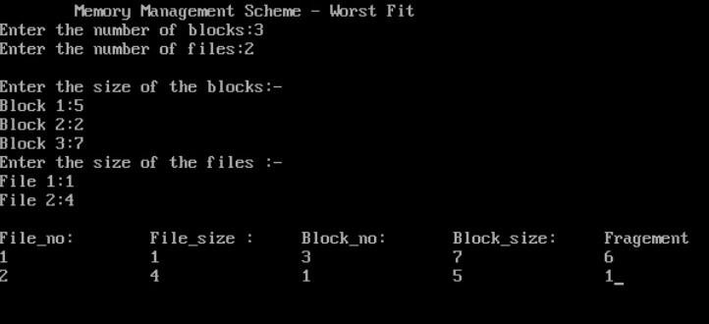

1. **Construct a C program to implement best fit algorithm ofmemory management.**

# PROGRAM:

#include <stdio.h>

#define MAX_MEMORY 1000int memory[MAX_MEMORY];

// Function to initialize memoryvoid initializeMemory() {

for (int i = 0; i < MAX_MEMORY; i++) {

memory[i] = -1; // -1 indicates that the memory is unallocated

}

}

// Function to display memory statusvoid displayMemory() {

int i, j;

int count = 0; printf("Memory Status:\n");

for (i = 0; i < MAX_MEMORY; i++) {

if (memory[i] == -1) { count++;

j = i;

while (memory[j] == -1 && j < MAX_MEMORY) {j++;

}

printf("Free memory block %d-%d\n", i, j - 1);i = j - 1;

}

}

if (count == 0) {

printf("No free memory available.\n");

}

}

// Function to allocate memory using best-fit algorithmvoid allocateMemory(int processId, int size) {

int start = -1;

int blockSize = MAX_MEMORY;int bestStart = -1;

int bestSize = MAX_MEMORY;

for (int i = 0; i < MAX_MEMORY; i++) {if (memory[i] == -1) {

if (blockSize == MAX_MEMORY) {start = i;

}

blockSize++;

} else {

if (blockSize >= size && blockSize < bestSize) {bestSize

= blockSize; bestStart = start;

}

blockSize = 0;

}

}

if (bestSize >= size) {

for (int i = bestStart; i < bestStart + size; i++) { memory[i] = processId;

}

printf("Allocated memory block %d-%d to Process %d\n", bestStart,bestStart + size - 1, processId);

} else {

printf("Memory allocation for Process %d failed (not enough contiguous memory).\n", processId);

}

}

// Function to deallocate memory

void deallocateMemory(int processId) {

for (int i = 0; i < MAX_MEMORY; i++) {if (memory[i] == processId) {

memory[i] = -1;

}

}

printf("Memory released by Process %d\n", processId);

}

int main() { initializeMemory(); displayMemory();

allocateMemory(1, 200); displayMemory();

allocateMemory(2, 300); displayMemory();

deallocateMemory(1); displayMemory();

allocateMemory(3, 400); displayMemory();

return 0;

}

# OUTPUT:

1. **Construct a C program to implement first fit algorithm ofmemory management.**

# PROGRAM:

#include <stdio.h>

#define MAX_MEMORY 1000int memory[MAX_MEMORY];

// Function to initialize memoryvoid initializeMemory() {

for (int i = 0; i < MAX_MEMORY; i++) {

memory[i] = -1; // -1 indicates that the memory is unallocated

}

}

// Function to display memory statusvoid displayMemory() {

int i, j;

int count = 0; printf("Memory Status:\n");

for (i = 0; i < MAX_MEMORY; i++) {

if (memory[i] == -1) { count++;

j = i;

while (memory[j] == -1 && j < MAX_MEMORY) {j++;

}

printf("Free memory block %d-%d\n", i, j - 1);i = j - 1;

}

}

if (count == 0) {

printf("No free memory available.\n");

}

}

// Function to allocate memory using first-fit algorithmvoid allocateMemory(int processId, int size) {

int start = -1;

int blockSize = 0;

for (int i = 0; i < MAX_MEMORY; i++) {if (memory[i] == -1) {

if (blockSize == 0) { start = i;

}

blockSize++;

} else {

blockSize = 0;

}

if (blockSize >= size) { break;

}

}

if (blockSize >= size) {

for (int i = start; i < start + size; i++) { memory[i] = processId;

}

printf("Allocated memory block %d-%d to Process %d\n", start, start +size - 1, processId);

} else {

printf("Memory allocation for Process %d failed (not enough contiguous memory).\n", processId);

}

}

// Function to deallocate memory

void deallocateMemory(int processId) {

for (int i = 0; i < MAX_MEMORY; i++) {if (memory[i] == processId) {

memory[i] = -1;

}

}

printf("Memory released by Process %d\n", processId);

}

int main() { initializeMemory(); displayMemory();

allocateMemory(1, 200); displayMemory();

allocateMemory(2, 300); displayMemory();

deallocateMemory(1); displayMemory();

allocateMemory(3, 400); displayMemory();

return 0;

}

# OUTPUT:

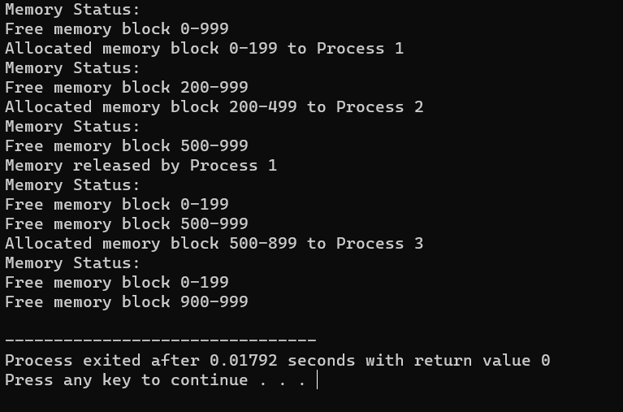

1. **Design a C program to demonstrate UNIX system calls for filemanagement.**

# PROGRAM:

#include <stdio.h> #include <stdlib.h> #include <unistd.h> #include <fcntl.h> #include <sys/types.h> #include <sys/stat.h>

int main() { int fd;

char buffer[100];

// Creating a new file

fd = creat("sample.txt", S_IRWXU);if (fd

== -1) {

perror("create"); exit(1);

} else {

printf("File 'sample.txt' created successfully.\n");close(fd);

}

// Opening an existing file for writing

fd = open("sample.txt", O_WRONLY | O_APPEND);if (fd ==

-1) {

perror("open"); exit(1);

} else {

printf("File 'sample.txt' opened for writing.\n");

}

// Writing data to the file write(fd, "Hello, World!\n", 14);

printf("Data written to 'sample.txt'.\n"); close(fd);

// Opening the file for reading

fd = open("sample.txt", O_RDONLY);if (fd

== -1) {

perror("open"); exit(1);

} else {

printf("File 'sample.txt' opened for reading.\n");

}

// Reading data from the file

int bytesRead = read(fd, buffer, sizeof(buffer));if (bytesRead == -1) {

perror("read"); exit(1);

} else {

printf("Data read from 'sample.txt':\n"); write(STDOUT_FILENO, buffer, bytesRead);

}

close(fd);

// Deleting the file

if (remove("sample.txt") == -1) { perror("remove");

exit(1);

} else {

printf("File 'sample.txt' deleted.\n");

}

return 0;

}

# OUTPUT:

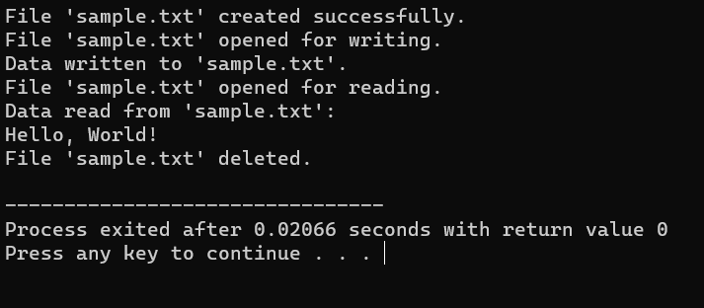

1. **Construct a C program to implement the I/O system calls ofUNIX (fcntl, seek, stat, opendir, readdir)**

# PROGRAM:

#include<stdio.h> #include<fcntl.h> #include<errno.h> extern int errno; int main()

{

int fd = open("foo.txt", O_RDONLY | O_CREAT); printf("fd = %d\n", fd);

if (fd ==-1)

{

printf("Error Number % d\n", errno); perror("Program");

}

return 0;

}

# OUTPUT:

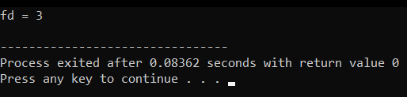

1. **Construct a C program to implement the file managementoperations.**

# PROGRAM:

#include <stdio.h> #include <stdlib.h> int main() {

FILE *file;

file = fopen("example.txt", "w");if (file == NULL) {

printf("Error opening the file for writing.\n");return 1;

}

fprintf(file, "Hello, World!\n");

fprintf(file, "This is a C file management example.\n"); fclose(file);

file = fopen("example.txt", "r");if (file == NULL) {

printf("Error opening the file for reading.\n");return 1;

}

char buffer[100];

while (fgets(buffer, sizeof(buffer), file) != NULL) { printf("%s", buffer);

}

fclose(file);

return 0;

}

# OUTPUT:

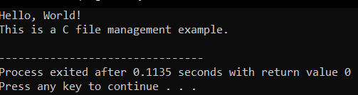

1. **Develop a C program for simulating the function of ls UNIXCommand.**

# PROGRAM:

#include<stdio.h> #include<dirent.h>

int main()

{

char fn[10], pat[10], temp[200];FILE

*fp;

printf("\n Enter file name : "); scanf("%s", fn);

printf("Enter the pattern: "); scanf("%s", pat);

fp = fopen(fn, "r");

while (!feof(fp)) { fgets(temp, sizeof(fp), fp);if (strcmp(temp, pat))

printf("%s", temp);

}

fclose(fp); return 1;

}

# OUTPUT:

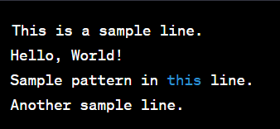

1. **Write a C program for simulation of GREP UNIX command.**

# PROGRAM :

#include <stdio.h> #include <stdlib.h> #include <string.h>

#define MAX_LINE_LENGTH 1024

void searchFile(const char *pattern, const char *filename)

{

FILE *file = fopen(filename, "r");

if (file == NULL) { perror("Error opening file");exit(1);

}

char line[MAX_LINE_LENGTH]; while (fgets(line, sizeof(line), file)) {

if (strstr(line, pattern) != NULL) { printf("%s", line);

}

}

fclose(file);

}

int main(int argc, char *argv[]) {if (argc != 3) {

fprintf(stderr, "Usage: %s <pattern> <filename>\n", argv[0]);return 1;

}

const char *pattern = argv[1]; const char *filename = argv[2]; searchFile(pattern, filename);

return 0;

}

# OUTPUT:

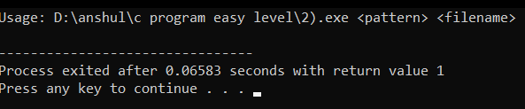

1. **Write a C program to simulate the solution of ClassicalProcess Synchronization Problem**

# PROGRAM:

#include <stdio.h> #include <stdlib.h> int mutex = 1;

int full = 0;

int empty = 10, x = 0; void producer()

{

--mutex;

++full;

--empty; x++;

printf("\nProducer produces" "item %d",

x);

++mutex;

}

void consumer()

{

--mutex;

--full;

++empty;

printf("\nConsumer consumes ""item

%d",

x);

x--;

++mutex;

}

int main()

{

int n, i;

printf("\n1. Press 1 for Producer"

"\n2. Press 2 for Consumer""\n3. Press 3 for Exit");

#pragma omp critical for (i

= 1; i > 0; i++)

{

printf("\nEnter your choice:"); scanf("%d", &n);

switch (n) { case 1:

if ((mutex == 1)

&& (empty != 0)) { producer();

}

else

{

printf("Buffer is full!");

}

break; case 2:

if ((mutex == 1) && (full != 0)) { consumer();

}

else {

printf("Buffer is empty!");

}

break;

case 3:

exit(0); break;

}

}

}

# OUTPUT:

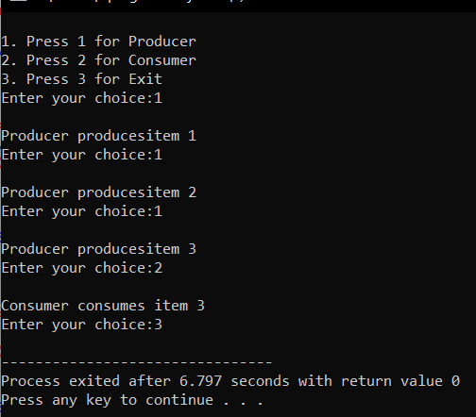

1. **Write C programs to demonstrate the following thread relatedconcepts.**

# PROGRAM:

#include <pthread.h> #include <stdio.h> #include <stdlib.h> void* func(void* arg)

{

pthread_detach(pthread_self());printf("Inside the thread\n"); pthread_exit(NULL);

}

void fun()

{

pthread_t ptid;

pthread_create(&ptid, NULL, &func, NULL); printf("This line may be printed"

" before thread terminates\n"); if(pthread_equal(ptid, pthread_self()))

{

printf("Threads are equal\n");

}

else

printf("Threads are not equal\n");

pthread_join(ptid, NULL); printf("This line will be printed""

after thread ends\n"); pthread_exit(NULL);

}

int main()

{

fun(); return 0;

}

# OUTPUT:

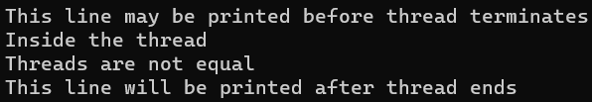

1. **Construct a C program to simulate the First in First Outpaging technique of memory management.**

**AIM:** Construct a C program to simulate the First in First Out pagingtechnique of memory management.

# ALGORITHM:

1. Create an array to represent the page frames in memory.
2. Initialize all page frames to -1, indicating that they are empty.
3. Initialize a queue to keep track of the order in which pages are loaded intomemory.
4. Initialize variables for page hits and page faults to zero.
5. Read the reference string (sequence of page numbers) from the user or usea predefined array.
6. For each page in the reference string, do the following:
7. Check if the page is already in memory (a page hit).

If it's a page hit, update the display and move to the next page.

1. If it's a page fault (page not in memory), do the following: Increment the page fault count.
2. Remove the oldest page in memory (the one at the front of the queue).
3. .Load the new page into the memory and enqueue it.
4. Update the display to show the page replacement.
5. Continue this process for all pages in the reference string.
6. After processing all pages, display the total number of page faults.

# PROGRAM:

#include <stdio.h>

#define MAX_FRAMES 3 // Maximum number of frames in memory void printFrames(int frames[], int n) {for

(int i = 0; i < n; i++) { if (frames[i] == -1) {

printf(" - ");

} else {

printf(" %d ", frames[i]);

}

}

printf("\n");

}

int main() {

int referenceString[] = {7, 0, 1, 2, 0, 3, 0, 4, 2, 3, 0, 3, 2}; int n =

sizeof(referenceString) / sizeof(referenceString[0]); int frames[MAX_FRAMES];

int framePointer = 0; // Points to the current frame to be replaced

for (int i = 0; i < MAX_FRAMES; i++)

{

frames[i] = -1; // Initialize all frames to -1 (indicating empty)

}

printf("Reference String: ");for (int i = 0; i < n; i++) {

printf("%d ", referenceString[i]);

}printf("\n\n");

printf("Page Replacement Order:\n"); for (int i = 0; i < n; i++) {

int page = referenceString[i];int pageFound = 0;

// Check if the page is already in memoryfor (int j

= 0; j < MAX_FRAMES; j++) {

if (frames[j] == page) { pageFound = 1; break;

}

}

if (!pageFound) {

printf("Page %d -> ", page); frames[framePointer] = page;

framePointer = (framePointer + 1) % MAX_FRAMES; printFrames(frames, MAX_FRAMES);

}

}

return 0;

}

# OUTPUT:

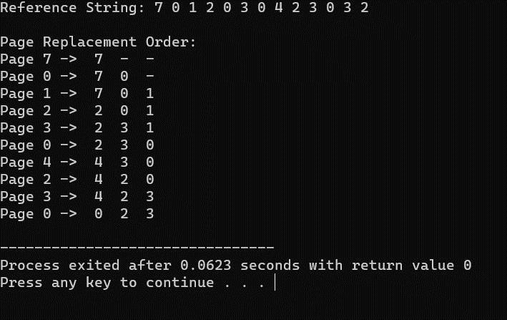

1. **Construct a C program to simulate the Least RecentlyUsed paging technique of memory management.**

**AIM:** Construct a C program to simulate the Least Recently Used pagingtechnique of memory management.

# ALGORITHM:

* 1. Create an array to represent the page frames in memory.
  2. Initialize all page frames to -1, indicating that they are empty.
  3. Create a queue or a data structure (e.g., a doubly-linked list) tomaintain the order of pages based on their usage history.
  4. Initialize a counter for page hits and page faults to zero.
  5. Read the reference string (sequence of page numbers) from the user oruse a predefined array.
  6. For each page in the reference string, do the following:
  7. Check if the page is already in memory (a page hit).
  8. If it's a page hit, update the position of the page in the usage historydata structure to indicate it was recently used.
  9. If it's a page fault (page not in memory), do the following:
  10. Increment the page fault count.
  11. Find the least recently used page in the usage history data structure(e.g., the front of the queue or the tail of the list).
  12. Remove the least recently used page from memory and the usagehistory.
  13. Load the new page into memory and add it to the back of the usagehistory.
  14. Update the display to show the page replacement. 15.Continue this process for all pages in the reference string.
  15. After processing all pages, display the total number of page faults.

# PROGRAM:

#include <stdio.h> #include <stdlib.h>

#define MAX_FRAMES 3

void printFrames(int frames[], int n) {for (int i = 0; i < n; i++) {

if (frames[i] == -1) {

printf(" - ");

} else {

printf(" %d ", frames[i]);

}

}

printf("\n");

}

int main() {

int frames[MAX_FRAMES];

int usageHistory[MAX_FRAMES]; // To store the usage history ofpages for (int i = 0; i < MAX_FRAMES; i++) {

frames[i] = -1; // Initialize frames to -1 (empty) usageHistory[i] = 0; // Initialize usage history

}

int pageFaults = 0;

int referenceString[] = {7, 0, 1, 2, 0, 3, 0, 4, 2, 3, 0, 3, 2}; int n = sizeof(referenceString) / sizeof(referenceString[0]);

printf("Reference String: ");for (int i = 0; i < n; i++) {

printf("%d ", referenceString[i]);

}

printf("\n\n");

printf("Page Replacement Order:\n");for (int i = 0; i < n; i++) {

int page = referenceString[i];int pageFound = 0;

// Check if the page is already in memory (a page hit)for (int j

= 0; j < MAX_FRAMES; j++) {

if (frames[j] == page) { pageFound = 1;

// Update the usage history by incrementing other pagesfor (int k

= 0; k < MAX_FRAMES; k++) {

if (k != j) { usageHistory[k]++;

}

}

usageHistory[j] = 0; // Reset the usage counter for the used pagebreak;

}

}

if (!pageFound) {

printf("Page %d -> ", page);

used)

// Find the page with the maximum usage counter (least recently

int lruPage = 0;

for (int j = 1; j < MAX_FRAMES; j++) {

if (usageHistory[j] > usageHistory[lruPage]) {lruPage

= j;

}

}

int replacedPage = frames[lruPage]; frames[lruPage] = page; usageHistory[lruPage] = 0;

if (replacedPage != -1) {

printf("Replace %d with %d: ", replacedPage, page);

} else {

printf("Load into an empty frame: ");

}

printFrames(frames, MAX_FRAMES); pageFaults++;

}

}

printf("\nTotal Page Faults: %d\n", pageFaults);

return 0;

}

# OUTPUT:

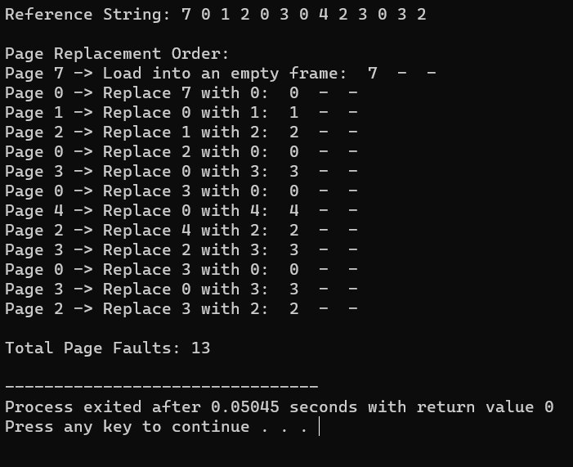

1. **Construct a C program to simulate the optimal pagingtechnique of memory management**

**AIM:** Construct a C program to simulate the optimal paging technique ofmemory management

# ALGORITHM:

* 1. Create an array to represent the page frames in memory.
  2. Initialize all page frames to -1, indicating that they are empty.
  3. Initialize a variable for page faults to zero.
  4. Read the reference string (sequence of page numbers) from the useror use a predefined array.
  5. For each page in the reference string, do the following:
  6. Check if the page is already in memory (a page hit).
  7. If it's a page hit, move to the next page.
  8. If it's a page fault (page not in memory), do the following:
  9. Increment the page fault count.
  10. Calculate the future references of each page in memory by scanningthe remaining part of the reference string.
  11. Find the page that will not be used for the longest time in the future(the optimal page to replace).
  12. Replace the optimal page with the new page. 13.Continue this process for all pages in the reference string.
  13. After processing all pages, display the total number of page faults.

# PROGRAM:

#include <stdio.h> #include <stdlib.h>

#define MAX_FRAMES 3

void printFrames(int frames[], int n) {for (int i = 0; i < n; i++) {

if (frames[i] == -1) {

printf(" - ");

} else {

printf(" %d ", frames[i]);

}

}

printf("\n");

}

int main() {

int frames[MAX_FRAMES];

for (int i = 0; i < MAX_FRAMES; i++) { frames[i] = -1;

// Initialize frames to -1 (empty)

}

int pageFaults = 0;

int referenceString[] = {7, 0, 1, 2, 0, 3, 0, 4, 2, 3, 0, 3, 2}; int n = sizeof(referenceString) / sizeof(referenceString[0]);

printf("Reference String: ");for (int i = 0; i < n; i++) {

printf("%d ", referenceString[i]);

}

printf("\n\n");

printf("Page Replacement Order:\n");for (int i = 0; i < n; i++) {

int page = referenceString[i]; int pageFound = 0;

// Check if the page is already in memory (a page hit)for (int j

= 0; j < MAX_FRAMES; j++) {

if (frames[j] == page) { pageFound = 1; break;

}

}

if (!pageFound) {

printf("Page %d -> ", page);

int optimalPage = -1; int farthestDistance = 0;

for (int j = 0; j < MAX_FRAMES; j++) {int futureDistance = 0;

for (int k = i + 1; k < n; k++) {

if (referenceString[k] == frames[j]) {break;

}

futureDistance++;

}

if (futureDistance > farthestDistance) { farthestDistance = futureDistance; optimalPage = j;

}

}

frames[optimalPage] = page;

printFrames(frames, MAX_FRAMES); pageFaults++;

}

}

printf("\nTotal Page Faults: %d\n", pageFaults);

return 0;

}

# OUTPUT

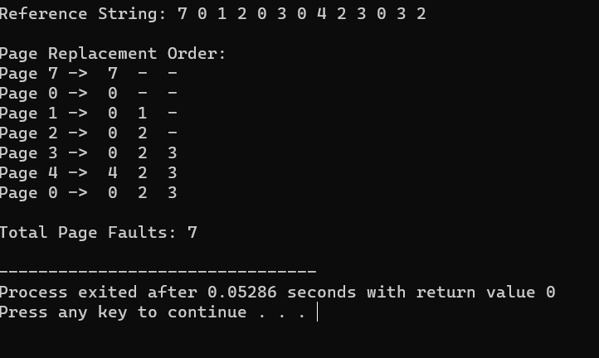

1. **Consider a file system where the records of the file are stored one after another both physically and logically. A record of the filecan only be accessed by reading all the previous records. Design aC program to simulate the file allocation strategy.**

**AIM:** Consider a file system where the records of the file are stored one after another both physically and logically. A record of the file can only be accessed

by reading all the previous records. Design a C program to simulate the fileallocation strategy.

# ALGORITHM:

* 1. Define the structure of a record that will be stored in the file.
  2. Create a file to represent the sequential file.
  3. Write records to the file sequentially, one after the other.
  4. To read a specific record:
  5. Prompt the user for the record number they want to access.
  6. Read and display all records from the beginning of the file up to therequested record.
  7. Continue this process until the user decides to exit.

# PROGRAM:

#include <stdio.h> #include <stdlib.h>

// Structure to represent a recordstruct Record {

int recordNumber;

char data[256]; // Adjust the size as needed for your records

};

int main() { FILE *file;

struct Record record;int recordNumber;

// Open or create a file in write mode (for writing records)file = fopen("sequential_file.txt", "w");

if (file == NULL) {

printf("Error opening the file.\n");

return 1;

}

// Write records sequentially to the file

printf("Enter records (Enter '0' as record number to exit):\n");while (1)

{

printf("Record Number: "); scanf("%d", &record.recordNumber);if (record.recordNumber == 0) {

break;

}

// Input data for the record printf("Data: ");

scanf(" %[^\n]", record.data);

// Write the record to the file

fwrite(&record, sizeof(struct Record), 1, file);

}

fclose(file);

// Reopen the file in read mode (for reading records)file = fopen("sequential_file.txt", "r");

if (file == NULL) {

printf("Error opening the file.\n"); return 1;

}

// Read a specific record from the filewhile

(1) {

printf("Enter the record number to read (0 to exit): "); scanf("%d", &recordNumber);

if (recordNumber == 0) { break;

}

// Read and display records up to the requested recordwhile (fread(&record, sizeof(struct Record), 1, file)) {

printf("Record Number: %d\n", record.recordNumber); printf("Data: %s\n", record.data);

if (record.recordNumber == recordNumber) {break;

}

}

rewind(file); // Reset the file pointer to the beginning of the file

}

fclose(file); return 0;

}

# OUTPUT:

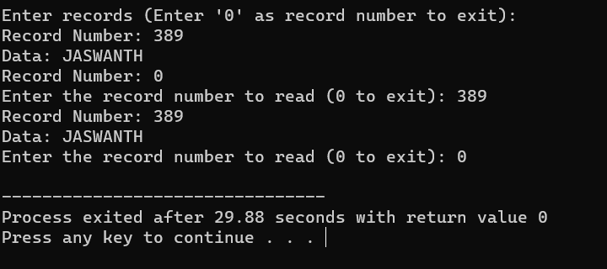

1. **Consider a file system that brings all the file pointers together into an index block. The ith entry in the index block points to the ith block of the file. Design a C program to simulate the file**

**allocation strategy.**

**AIM:** Consider a file system that brings all the file pointers together into an index block. The ith entry in the index block points to the ith block of the file.Design a C program to simulate the file allocation strategy.

# ALGORITHM:

* 1. Define the structure of a block that will be stored in the file.
  2. Create a file to represent the indexed file.
  3. Initialize an index block that contains pointers to data blocks.
  4. To write a new block:
  5. Prompt the user for the block number and the data to be written to theblock.
  6. Update the corresponding entry in the index block to point to the new datablock.
  7. Write the data block to the file.
  8. To read a specific block:
  9. Prompt the user for the block number they want to access.
  10. Use the index block to find the pointer to the requested data block.11.Read and display the data in the requested data block.

12.Continue this process until the user decides to exit.

# PROGRAM:

#include <stdio.h> #include <stdlib.h>

// Structure to represent a block struct Block {

int blockNumber;

char data[256]; // Adjust the size as needed for your blocks

};

int main() { FILE *file;

struct Block block;int blockNumber;

// Create an index block that contains pointers to data blocksint indexBlock[100] = {0}; // Adjust the size as needed

// Open or create a file in write mode (for writing blocks)file =

fopen("indexed_file.txt", "w"); if (file == NULL) {

printf("Error opening the file.\n"); return 1;

}

// Write blocks and update the index block

printf("Enter blocks (Enter '0' as block number to exit):\n");while (1)

{

printf("Block Number: "); scanf("%d", &block.blockNumber);if

(block.blockNumber == 0) { break;

}

// Input data for the block printf("Data: ");

scanf(" %[^\n]", block.data);

// Write the block to the file

fwrite(&block, sizeof(struct Block), 1, file);

// Update the index block with the pointer to the data block indexBlock[block.blockNumber] = ftell(file) - sizeof(struct Block);

}

fclose(file);

// Reopen the file in read mode (for reading blocks)file = fopen("indexed_file.txt", "r");

if (file == NULL) {

printf("Error opening the file.\n"); return 1;

}

// Read a specific block from the filewhile

(1) {

printf("Enter the block number to read (0 to exit): "); scanf("%d", &blockNumber);

if (blockNumber == 0) { break;

}

if (indexBlock[blockNumber] == 0) { printf("Block not found.\n");

} else {

// Seek to the data block using the index block fseek(file, indexBlock[blockNumber], SEEK_SET);fread(&block, sizeof(struct Block), 1, file);

printf("Block Number: %d\n", block.blockNumber); printf("Data: %s\n", block.data);

}

}

fclose(file); return 0;

}

# OUTPUT:

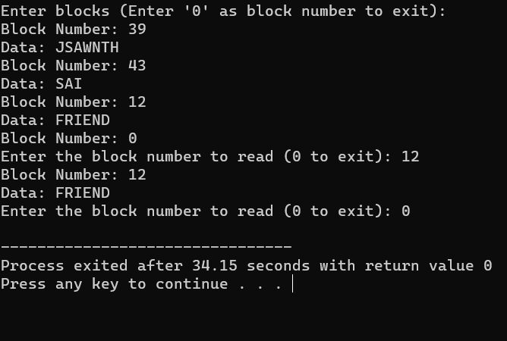

1. **With linked allocation, each file is a linked list of disk blocks;the disk blocks may be scattered anywhere on the disk. The**

**directory contains a pointer to the first and last blocks of the file.Each block contains a pointer to the next block. Design a C program to simulate the file allocation strategy.**

**AIM:** With linked allocation, each file is a linked list of disk blocks; the disk blocks may be scattered anywhere on the disk. The directory contains a pointerto the first and last blocks of the file. Each block contains a pointer to the next block. Design a C program to simulate the file allocation strategy.

# ALGORITHM:

* 1. Define the structure of a block that will be stored in the file. Each blockcontains a pointer to the next block.
  2. Create a file to represent the linked allocation.
  3. Create a directory entry for the file containing a pointer to the first and lastblocks.
  4. To write a new block:
  5. Prompt the user for the block data.
  6. Allocate a new block in the file.
  7. If it's the first block, update the directory entry to point to it as both the firstand last block.
  8. If it's not the first block, update the previous block to point to the newblock.
  9. Update the new block's pointer to the next block (usually NULL for the lastblock).
  10. To read a specific block:
  11. Prompt the user for the block number they want to access.12.Use the directory entry to find the first block of the file.

13.Traverse the linked list of blocks until you reach the desired block.14.Read and display the data in the requested block.

15. Continue this process until the user decides to exit.

# PROGRAM:

#include <stdio.h> #include <stdlib.h>

// Structure to represent a block struct Block {

char data[256]; // Adjust the size as needed for your blocksstruct Block* next;

};

int main() {

struct Block* firstBlock = NULL; // Pointer to the first block in the linkedlist struct Block* lastBlock = NULL; // Pointer to the last block in the linkedlist

int blockCount = 0; // Count of blocks in the linked list

int blockNumber; char data[256]; char choice;

printf("Linked Allocation Simulation\n");

while (1) {

printf("Enter 'W' to write a block, 'R' to read a block, or 'Q' to quit: ");scanf("

%c", &choice);

if (choice == 'Q' || choice == 'q') { break;

}

if (choice == 'W' || choice == 'w') { printf("Enter data for the block: "); scanf(" %[^\n]", data);

// Create a new block

struct Block* newBlock = (struct Block*)malloc(sizeof(struct Block));for (int i = 0; i < 256; i++) {

newBlock->data[i] = data[i];

}

newBlock->next = NULL;

if (blockCount == 0) {

// This is the first block firstBlock = newBlock; lastBlock = newBlock;

} else {

// Link the new block to the last block lastBlock->next = newBlock; lastBlock = newBlock;

}

blockCount++;

} else if (choice == 'R' || choice == 'r') {

printf("Enter the block number to read (1-%d): ", blockCount); scanf("%d", &blockNumber);

if (blockNumber < 1 || blockNumber > blockCount) { printf("Invalid block number. The valid range is 1-%d.\n",

blockCount);

} else {

struct Block* currentBlock = firstBlock;for (int i = 1; i < blockNumber; i++) {

currentBlock = currentBlock->next;

}

printf("Block %d Data: %s\n", blockNumber, currentBlock->data);

}

}

}

// Free the allocated memory for blocks before exitingstruct Block* currentBlock = firstBlock;

while (currentBlock != NULL) {

struct Block* nextBlock = currentBlock->next;

free(currentBlock); currentBlock = nextBlock;

}

return 0;

}

# OUTPUT:

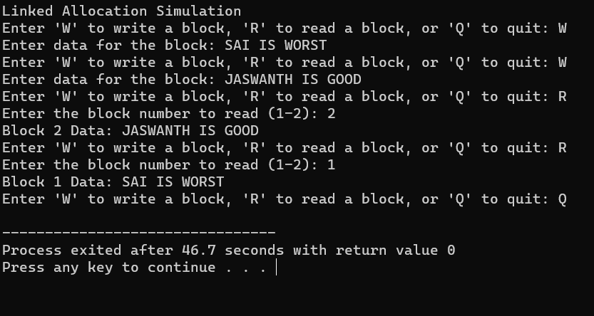

1. **Construct a C program to simulate the First Come FirstServed disk scheduling algorithm.**

**AIM:-** Construct a C program to simulate the First Come First Serveddisk scheduling algorithm.

# ALGORITHM:-

1. Start at the current position of the disk head.
2. For each disk request in the queue:
   * Move the disk head to the requested track.
   * Calculate the seek time as the absolute difference between the newposition of the disk head and the previous position.
   * Add the seek time to the total seek time.
   * Update the previous position of the disk head to the current position.
3. Repeat step 2 for all disk requests in the queue.
4. After serving all the requests, calculate and display the total seek time.
5. Calculate and display the average seek time, which is the total seek timedivided by the number of requests.

# PROGRAM:-

#include <stdio.h> #include <stdlib.h>

int main() {

int n, head, seek_time = 0;

printf("Enter the number of disk requests: "); scanf("%d", &n);

int request_queue[n];

printf("Enter the disk request queue:\n");for (int i = 0; i < n; i++) {

scanf("%d", &request_queue[i]);

}

printf("Enter the initial position of the disk head: "); scanf("%d", &head);

// FCFS Scheduling

printf("\nFCFS Disk Scheduling:\n");

printf("Head Movement Sequence: %d", head);for (int i = 0; i < n; i++) {

seek_time += abs(head - request_queue[i]);head = request_queue[i];

printf(" -> %d", head);

}

printf("\nTotal Seek Time: %d\n", seek_time); printf("Average Seek Time: %.2f\n", (float) seek_time / n);

return 0;

}

# OUTPUT:-

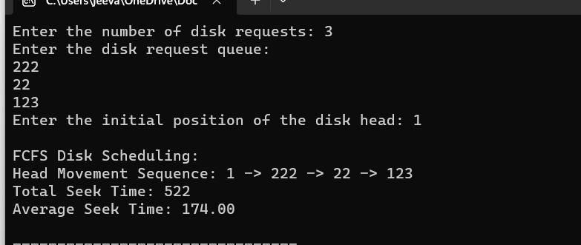

1. **Design a C program to simulate SCAN disk schedulingalgorithm**.

**AIM:-** Design a C program to simulate SCAN disk schedulingalgorithm.

# ALGORITHM:-

* 1. Determine the direction of movement (inward or outward) basedon the queue of pending requests and the current position.
  2. While servicing requests in the selected direction:
     + Move the disk head to the next track in the current direction.
     + Calculate the seek time as the absolute difference between the newposition of the disk head and the previous position.
     + Add the seek time to the total seek time.
     + Update the previous position of the disk head to the currentposition.
  3. If there are no more requests in the current direction, changedirection to the opposite direction.
  4. Repeat step 3 until all requests are serviced.
  5. After serving all the requests, calculate and display the total seektime.
  6. Calculate and display the average seek time, which is the total seektime divided by the number of requests.

**PROGRAM:**

#include <stdio.h> #include <stdlib.h>

int main() {

int n, head, seek_time = 0;

printf("Enter the number of disk requests: "); scanf("%d", &n);

int request_queue[n];

printf("Enter the disk request queue:\n"); for (int i = 0; i < n; i++) { scanf("%d",

&request_queue[i]);

}

printf("Enter the initial position of the disk head: "); scanf("%d", &head);

// Sort the request queue to simplify SCAN algorithmfor (int i

= 0; i < n - 1; i++) {

for (int j = i + 1; j < n; j++) {

if (request_queue[i] > request_queue[j]) {int temp = request_queue[i]; request_queue[i] = request_queue[j]; request_queue[j] = temp;

}

}

}

// SCAN (Elevator) Scheduling

printf("\nSCAN (Elevator) Disk Scheduling:\n");int start

= 0;

int end = n - 1;

int current_direction = 1; // 1 for moving right, -1 for moving left

while (start <= end) {

if (current_direction == 1) {

for (int i = start; i <= end; i++) { if (request_queue[i] >= head) {

seek_time += abs(head - request_queue[i]);head = request_queue[i];

start = i + 1; break;

}

}

current_direction = -1; // Change direction

} else {

for (int i = end; i >= start; i--) {

if (request_queue[i] <= head) {

seek_time += abs(head - request_queue[i]);head = request_queue[i];

end = i - 1;

break;

}

}

current_direction = 1; // Change direction

}

}

printf("Total Seek Time: %d\n", seek_time); printf("Average Seek Time: %.2f\n", (float)seek_time / n);

return 0;

}

**Output:-**

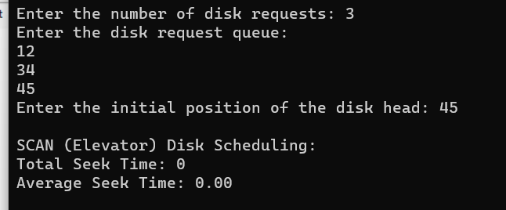

1. **Develop a C program to simulate C-SCAN disk schedulingalgorithm**.

**AIM:-** Develop a C program to simulate C-SCAN disk schedulingalgorithm.

# ALGORITHM:-

1. Start at the current position of the disk head.
2. Set the direction of movement to one side (e.g., right).
3. While servicing requests in the selected direction:
   * Move the disk head to the next track in the current direction.
   * Calculate the seek time as the absolute difference between the newposition of the disk head and the previous position.
   * Add the seek time to the total seek time.
   * Update the previous position of the disk head to the currentposition.
4. If there are no more requests in the current direction:
   * Move the disk head to the end of the disk in the current direction.
   * Change direction to the opposite side (e.g., left).
   * Continue servicing requests in the new direction.
5. Repeat step 3 and step 4 until all requests are serviced.
6. After serving all the requests, calculate and display the total seektime.
7. Calculate and display the average seek time, which is the total seektime divided by the number of requests.

# PROGRAM:-

#include <stdio.h> #include <stdlib.h>

int main() {

int n, head, seek_time = 0;

printf("Enter the number of disk requests: "); scanf("%d", &n);

int request_queue[n];

printf("Enter the disk request queue:\n");for (int i = 0; i < n; i++) {

scanf("%d", &request_queue[i]);

}

printf("Enter the initial position of the disk head: "); scanf("%d", &head);

// Sort the request queue for simplicityfor (int i = 0; i < n - 1; i++) {

for (int j = i + 1; j < n; j++) {

if (request_queue[i] > request_queue[j]) {int temp = request_queue[i]; request_queue[i] = request_queue[j]; request_queue[j] = temp;

}

}

}

// C-SCAN Scheduling

printf("\nC-SCAN Disk Scheduling:\n");int start = 0;

int end = n - 1;

while (start <= end) {

for (int i = start; i <= end; i++) { if (request_queue[i] >= head) {

seek_time += abs(head - request_queue[i]);head = request_queue[i];

start = i + 1;

}

}

// Move the head to the end in the current direction seek_time += abs(head - 0);

head = 0;

// Change direction to the opposite side seek_time += abs(head - request_queue[end]);head = request_queue[end];

end = n - 2; // Exclude the last request, as it has already been served

}

printf("Total Seek Time: %d\n", seek_time); printf("Average Seek Time: %.2f\n", (float)seek_time / n);

return 0;

}

# OUTPUT:-

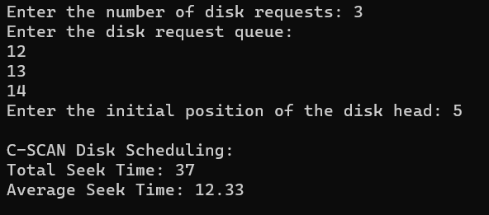

1. **Illustrate the various File Access Permission and different typesusers in Linux.**

**AIM:** Illustrate the various File Access Permission and different typesusers in Linux.

# ALGORITHM:

1. Create a file or identify an existing file to demonstrate permissionsand users.
2. View the file's permissions using the ls -l command. The outputwill look something like this:

.txt

* + The first character (-) represents the file type (a dash indicates aregular file).
  + The next three characters (rw-) represent the permissions for thefile's owner (Read and Write, no Execute).
  + The next three characters (r--) represent the permissions for thefile's group (Read, no Write or Execute).
  + The last three characters (r--) represent the permissions for others(Read, no Write or Execute).
  + The number 1 represents the number of hard links to the file.
  + owner is the username of the file's owner.
  + group is the name of the file's group.
  + 1234 is the file's size in bytes.
  + Oct 19 10:30 is the last modification timestamp.
  + file.txt is the file name.

1. Use the chmod command to change the file's permissions. Forexample, to give the group write permission, use chmod g+w file.txt.
2. Re-run ls -l to confirm the updated permissions.
3. You can also change the file's owner and group using the chownand chgrp commands, respectively.
4. To create and manage user accounts, you can use the useradd andpasswd commands.

# PROGRAM:

#include <stdio.h> #include <stdlib.h> #include <sys/stat.h>

int main() {

char filename[] = "file.txt";

int new_permissions = S_IRUSR | S_IWUSR | S_IRGRP | S_IWGRP |S_IROTH; // rw-rw-

r--

if (chmod(filename, new_permissions) == 0) { printf("File permissions changed successfully.\n");

} else {

perror("chmod"); return 1;

}

return 0;

}

**OUTPUT:**

